**Isolation and characterization of Hydrocarbon-Degrading Bacteria from Oil-Contaminated Soil**

PROJECT REPORT

*Submitted in fulfilment of the requirements for the award of degree*

*of*

**BACHELOR OF TECHNOLOGY**

*in*

**BIOTECHNOLOGY**

*Under the guidance*

*of*

**Dr. Saurabh Bansal**

**Associate Professor**

*by*

**Richa Dhiman (211804)**

*to*



**DEPARTMENT OF BIOTECHNOLOGY AND BIOINFORMATICS**

Jaypee University of Information Technology, Solan

173234, Himachal Pradesh

**DECLARATION**

I hereby declare that the work presented in this report entitled ‘**Isolation and characterization of Hydrocarbon-Degrading Bacteria from Oil-Contaminated Soil**’ in the fulfilment of the requirements for the award of the degree of **Bachelor of Technology** in Biotechnology is submitted to the Department of Biotechnology and Bioinformatics, Jaypee University of Information Technology, Waknaghat. This is an authentic record of my own work carried out over a period from January to May 2025 under the supervision of Dr. Saurabh Bansal (Associate Professor, Department of Biotechnology and Bioinformatics).The matter embodied in the report has not been submitted for the award of any other degree or diploma.

(Student Signature with Date)

Student Name: Richa Dhiman

Roll No.: 211804

This is to certify that the above statement made by the candidate is true to the best of my knowledge.

(Supervisor Signature with Date)

Supervisor Name: Dr. Saurabh Bansal

Designation: Associate Professor

Department: Biotechnology & Bioinformatics

Dated

**CERTIFICATE**

This is to certify that the work which is being presented in the major project report titled “**Isolation and characterization of Hydrocarbon-Degrading Bacteria from Oil-Contaminated Soil**” in fulfilment of the requirements for the award of the degree of B.Tech in Biotechnology and submitted to the Department of Biotechnology & Bioinformatics, Jaypee University of Information Technology, Waknaghat, is an authentic record of work carried out by Richa Dhiman (211804) during the period from January to May 2025 under the supervision of Dr. Saurabh Bansal, Department of Biotechnology & Bioinformatics, Jaypee University of Information Technology, Waknaghat.

Dr. Saurabh Bansal

Associate Professor

Department of Biotechnology & Bioinformatics

Jaypee University of Information Technology, Waknaghat

Date:………………….

**ACKNOWLEDGEMENT**

Firstly, I express my sincere gratitude and thanks to the Almighty God for His divine blessings, which enabled me to successfully complete this project.

I extend my heartfelt thanks and deep sense of gratitude to my supervisor, Dr. Saurabh Bansal, Associate Professor, Department of Biotechnology and Bioinformatics, Jaypee University of Information Technology, Waknaghat. His profound knowledge, keen interest in Biotechnology, and unwavering guidance throughout the project has been instrumental in completing this work. His patience, constructive criticism, valuable advice, and constant encouragement have been invaluable in shaping this project.

I would also like to extend my appreciation to the teaching and non-teaching staff of the Department of Biotechnology and Bioinformatics for their kind support and assistance during this project. Additionally, I acknowledge and thank all individuals who have directly or indirectly contributed to the success of this project.

Finally, I would like to express my deepest gratitude to my parents for their constant support, encouragement, and patience, which motivated me to persevere throughout this journey.

Richa Dhiman

**TABLE OF CONTENTS**

|  |  |
| --- | --- |
| **CONTENTS** | **PAGE NO** |
| Declaration | I |
| Certificate | II |
| Acknowledgment | III |
| Abstract | VIII |
| **Chapter 1: Introduction** | 1-3 |
| **Chapter 2: Literature Review** | 4-25 |
| 2.1 Introduction to Oil Pollution | 4 |
| 2.2 Conventional Methods of Oil Remediation | 5 |
| 2.3 Concept of Bioremediation | 7 |
| 2.4 Microbial Degradation of Hydrocarbons | 9 |
| 2.5 Types of Hydrocarbon-Degrading Bacteria | 11 |
| 2.5.1 Major Genera Involved in Hydrocarbon Degradation | 12 |
| 2.5.2 Enzymatic andGenetic Adaptation | 13 |
| 2.5.3 Ecological Significance of Hydrocarbon-Degrading Bacteria | 14 |
| 2.6 Environmental Factors Influencing Biodegradation | 14 |
| 2.7 Enrichment and Isolation of Oil-Degrading Bacteria | 18 |
| 2.8 Recent Advances and Biotechnological Applications in remediation | 20 |
| 2.9 Research Gaps and Future Direction | 22 |
| **Chapter 3: Materials and Methodology** | 26-39 |
| 3.1 Sample Collection | 26 |
| 3.2 Preparation of Minimal Salt Media | 26 |
| 3.3 Enrichment and Isolation of Bacteria | 27 |
| 3.4 Gram’s Staining | 28 |
| 3.5 Biochemical Characterization of Isolates | 29 |
| 3.6 Genomic DNA Isolation | 33 |
| 3.7 Turbidity Analysis | 35 |
| 3.8 Optimization Analysis | 37 |
| 3.8.1 Evaluation of Different Nitrogen Sources | 37 |
| 3.8.2 Optimization of pH Using Peptone as Nitrogen Source | 38 |
| 3.8.3 Optimization of Temperature Using Peptone at pH 7.0 | 39 |
| **Chapter 4: Result** | 40-50 |
| 4.1 Isolation and Enrichment | 40 |
| 4.2 Morphological Observation and Gram Staining | 41 |
| 4.3 Biochemical Characterization | 42 |
| 4.4 DNA Extraction and Agarose Gel Electrophoresis | 43 |
| 4.5 Comparative Growth Analysis of Isolates | 44 |
| 4.6 Optimization Analysis | 45-50 |
| 4.6.1 Effect of Nitrogen Source | 45-46 |
| 4.6.2 Effect of Ph | 47-48 |
| 4.6.3 Effect of Temperature | 49-50 |
| **Chapter 5: Discussion** | 51 |
| **Chapter 6: Conclusion and Future Scope** | 52-53 |
| **Bibliography** | 54-56 |

**LIST OF FIGURES**

|  |  |  |
| --- | --- | --- |
| FIGURE NO. | CAPTION | PAGE NO. |
| FIG 1 | Bacterial growth of Isolate A Isolate B | 36 |
| FIG 2 | Flask with nitrogen source peptone, yeast extract and ammonium sulphate | 38 |
| FIG 3 | Flask with media at pH 5.0, pH 6.5, pH 7.0, pH 8.5 | 39 |
| FIG 4 | Bacterial colonies of Isolate A and B grown on MS agar plates show dense growth | 40 |
| FIG 5 | Microscopic view showing Gram-stained bacteria Isolated from oil-contaminated soil | 41 |
| FIG 6 | Agarose Gel Electrophoresis of Extracted DNA | 43 |
| FIG 7 | Line graph comparing OD₆₀₀ of Isolate A (peaking at ~4.8, Day 5) and Isolate B (peaking at ~4.5, Day 4) in MS broth with diesel and engine oil over 7 days, showing Isolate B’s faster initial growth and Isolate A’s higher, sustained growth. | 44 |
| FIG 8 | Bacterial growth in MS broth with diesel and nitrogen sources (peptone, yeast extract, ammonium sulphate) over 7 days (OD₆₀₀); peptone highest (OD ~6.8, Day 4), then yeast extract, ammonium sulphate lowest. | 47 |
| FIG 9 | Bacterial growth in MS broth with diesel at pH 5.0, 6.5, 7.0, 8.5 over 7 days (OD₆₀₀); pH 7.0 optimal (OD ~5.987, Day 6). | 48 |
| FIG 10 | Bacterial growth in MS broth with diesel at 25°C, 30°C, 37°C, 45°Cover 7 days (OD₆₀₀); highest at 37°C (Tem37, OD ~6.742, Day 5). | 50 |

**LIST OF OBSERVATION TABLES**

|  |  |  |
| --- | --- | --- |
| TABLE NO. | CAPTION | PAGE NO. |
| Table 4.3.1 | Biochemical test results showing positive catalase, MacConkey, and mannitol tests for both isolates. | 42 |
| Table 4.6.1 | OD₆₀₀ Values for Nitrogen Sources Over 7 Days | 45 |
| Table 4.6.2 | OD₆₀₀ Values at Different pH Levels Over 7 Days | 47 |
| Table 4.6.3 | OD₆₀₀ Values at Different Temperatures Over 7 Days | 49 |

**ABSTRACT**

Oil contamination is a significant environmental concern, primarily resulting from the widespread use and accidental release of petroleum products. These hydrocarbons persist in soil and water, posing long-term risks to ecosystems and human health. Conventional remediation techniques such as mechanical recovery, chemical dispersants, and incineration often fall short due to high costs and secondary pollution. In contrast, bioremediation offers a sustainable, eco-friendly solution by utilizing the natural metabolic capabilities of hydrocarbon-degrading microorganisms.

This project aimed to isolate and characterize bacteria capable of degrading hydrocarbons from oil-contaminated soil. Soil samples were collected and enriched using Minimal Salt (MS) media supplemented with diesel and engine oil as the sole carbon sources. Bacterial growth was monitored through optical density (OD) measurements, and isolates were further examined using Gram staining, biochemical tests (catalase, MR, VP, urease, mannitol, MacConkey), and genomic DNA extraction via the phenol-chloroform method. Two bacterial isolates (A and B) were compared through a 7-day growth curve analysis, and Isolate A demonstrated superior growth. Optimization experiments identified peptone as the most effective nitrogen source, with optimum degradation observed at pH 7 and 37°C.

The results indicate that the isolated strains, likely belonging to the genus *Pseudomonas*, hold strong potential for application in environmental bioremediation. These findings contribute to the development of microbial strategies for the efficient and sustainable cleanup of hydrocarbon-contaminated environments.

**CHAPTER 1**

**INTRODUCTION**

**Oil Contamination and its Environmental Impact**

Oil contamination has become one of the most pressing environmental concerns of the modern era, owing to the widespread use of petroleum-based products across industrial, transportation, and domestic sectors. The release of hydrocarbons—such as diesel, engine oil, and crude oil—into the environment occurs through a variety of channels, including accidental spills, leaks from pipelines, industrial discharge, and improper disposal of petroleum waste. These hydrocarbons, which are complex organic compounds, can persist in the environment for prolonged periods, wreaking havoc on ecosystems and human health.

When oil pollutants are released into soil and water, they disrupt the natural balance of these ecosystems by degrading soil fertility, contaminating water supplies, and threatening aquatic life. The accumulation of hydrocarbons in the food chain can lead to toxic effects on plants, animals, and ultimately humans (Liebeg and Cutright, 1999; Ting et al., 1999). The long-term persistence of oil contaminants makes them a significant concern for environmental restoration efforts. Traditional methods for oil spill cleanup, such as mechanical recovery, chemical dispersants, and incineration, often fall short in providing long-lasting solutions. These methods are not only costly but can also generate secondary pollutants, further exacerbating the environmental damage.

**The Need for Sustainable Solutions: Bioremediation**

Given the limitations of conventional cleanup methods, there is a growing need for more sustainable, eco-friendly alternatives. Bioremediation—the process of using microorganisms to degrade and remove environmental pollutants—has emerged as one of the most promising solutions to hydrocarbon contamination. Bioremediation relies on the natural metabolic capabilities of microorganisms, particularly bacteria, to break down complex hydrocarbons into simpler, non-toxic compounds such as carbon dioxide and water. This process is inherently environmentally friendly and can be performed in situ, meaning it can be applied directly at the contaminated site, reducing the need for costly and disruptive excavation or treatment.

While bioremediation offers a sustainable alternative, its efficiency is influenced by several factors, including the concentration and type of hydrocarbons, environmental conditions such as pH, temperature, and oxygen availability, as well as the bioavailability of the hydrocarbons themselves. Despite these challenges, bioremediation has shown great potential as an environmentally responsible method of addressing oil contamination and restoring ecological balance.

**Hydrocarbon-Degrading Microorganisms: The Catalysts for Bioremediation**

Certain microorganisms, especially bacteria, have evolved the ability to metabolize hydrocarbons as their primary source of carbon and energy. These microorganisms, commonly referred to as hydrocarbon-degrading bacteria, play a vital role in the bioremediation process. Well-known genera such as *Pseudomonas, Acinetobacter, and Rhodococcus* are capable of breaking down a wide range of both aliphatic and aromatic hydrocarbons (Hossain et al., 2023). These bacteria produce specialized enzymes, including monooxygenases and dioxygenases, which catalyze the oxidation of hydrocarbon molecules, ultimately breaking them down into simpler compounds.

An important aspect of hydrocarbon degradation is the production of biosurfactants, which are surface-active compounds produced by some bacteria. Biosurfactants enhance the solubility and bioavailability of hydrophobic hydrocarbons, making them more accessible to microbial enzymatic systems. By emulsifying the hydrocarbons, biosurfactants help overcome one of the major challenges in bioremediation: the limited solubility of hydrocarbons in water. This improves the efficiency of the degradation process, enabling the microorganisms to degrade a broader range of pollutants.

**Advantages and Challenges of Bioremediation**

Bioremediation offers several distinct advantages, making it an attractive option for the cleanup of oil-contaminated sites.

**Advantages:**

* **Cost-Effectiveness:** Unlike physical and chemical methods, bioremediation is relatively inexpensive, as it relies on naturally occurring or easily cultivated microorganisms.
* **Environmental Friendliness:** Bioremediation reduces the introduction of harmful chemicals into the environment, making it a safer and more eco-friendly approach to pollution management.
* **In Situ Application:** Bioremediation can be applied directly to contaminated sites without the need for soil excavation or extensive treatment, which reduces disruption to the surrounding environment.
* **Sustainability:** The use of indigenous microorganisms for bioremediation ensures that the process can be sustained over time, as these organisms are adapted to the local environment and can continue to function effectively in various conditions.

**Challenges:**

* **Hydrocarbon Toxicity:** High concentrations of hydrocarbons can inhibit microbial growth and enzymatic activity, limiting the effectiveness of the bioremediation process.
* **Environmental Conditions:** Factors such as temperature, pH, and oxygen levels significantly influence microbial activity and degradation rates.
* **Bioavailability of Hydrocarbons:** Many hydrocarbons are hydrophobic and poorly soluble in water, making it difficult for microorganisms to access and degrade them. This challenge can be addressed by using biosurfactants or chemical surfactants.
* **Time Requirements:** Bioremediation typically takes longer to achieve noticeable results compared to physical or chemical methods, often requiring weeks or even months.

**CHAPTER 2**

**LITERATURE REVIEW**

**2.1. Introduction to Oil Pollution**

Oil pollution refers to the release of crude oil or refined petroleum products into the environment, particularly in terrestrial (soil) or aquatic ecosystems. This pollution can occur through various human activities such as:

* Petroleum exploration (e.g., drilling operations),
* Refining processes (e.g., leakage during conversion to fuels),
* Transportation (e.g., pipeline leaks, ship spills),
* Accidental spills (e.g., industrial accidents, equipment failure).

The main pollutants in oil contamination are petroleum hydrocarbons, which are organic compounds made up mostly of carbon and hydrogen. These hydrocarbons include:

* Alkanes (straight or branched-chain hydrocarbons),
* Aromatic hydrocarbons (such as benzene, toluene),
* Polycyclic aromatic hydrocarbons (PAHs) (like naphthalene, anthracene), which are more complex and toxic.

These compounds are toxic, persistent, and hydrophobic (non-polar) in nature. This means:

* **Toxic:** They can poison living organisms, including beneficial soil microbes, plants, and animals.
* **Persistent:** They do not degrade easily, which means they can remain in the soil for years.
* **Hydrophobic and non-polar:** They do not mix well with water and tend to stick to soil particles, making them less mobile but harder to remove or degrade.

Because of these characteristics, oil contamination significantly alters the soil environment. It affects:

* **Physical properties:** It changes soil texture and aeration, often causing soil compaction and reduced water infiltration.
* **Chemical properties:** It disrupts nutrient cycling by limiting the availability of essential nutrients like nitrogen and phosphorus.
* **Biological properties:** It leads to a microbial imbalance, where native, beneficial microbial populations are suppressed or killed, and only oil-tolerant strains might survive.

These changes cause the soil to become less fertile, which can negatively affect plant growth and biodiversity. Additionally, the toxicity of petroleum hydrocarbons poses serious health risks to animals and humans through direct contact or by entering the food chain. Hence, oil pollution is not just an environmental nuisance but a major ecological and health hazard, necessitating effective remediation strategies like bioremediation to clean up contaminated soils.

**2.2. Conventional Methods of Oil Remediation**

Before the rise of environmentally friendly solutions like bioremediation, several conventional (traditional) methods have been used to clean up oil-contaminated soils. These techniques aim to remove, degrade, or isolate the pollutants using physical, chemical, or stabilization approaches. However, each of these has significant limitations, especially regarding sustainability and environmental safety.

**A. Physical Methods**

These involve the mechanical removal or separation of contaminated soil or hydrocarbons:

* **Soil Excavation:** Contaminated soil is physically dug out and either treated off-site or disposed of in landfills. While effective in removing pollutants quickly, it is disruptive to the ecosystem and expensive to transport and treat large volumes of soil.
* **Soil Washing:** Uses water or chemical solutions to wash out the hydrocarbons from the soil particles. However, it generates wastewater that needs further treatment, and its effectiveness is limited in soils with high clay or organic matter.
* **Thermal Treatment:** Involves heating the soil to high temperatures to vaporize and remove hydrocarbons. Although it can destroy most contaminants, it is energy-intensive, costly, and may also destroy beneficial soil microorganisms and structure.

**B. Chemical Methods**

These rely on chemical reactions to break down or neutralize pollutants:

* **Chemical Oxidation:** Strong oxidizing agents (e.g., hydrogen peroxide, ozone, or potassium permanganate) are introduced into the soil to degrade hydrocarbons into less harmful compounds. However, this can alter soil pH, kill native microbes, and is not always effective for all hydrocarbon types.
* **Dispersants and Solvents:** Chemicals are used to dissolve or break down oil into smaller particles, making it easier to remove or degrade. However, these agents can themselves be toxic, leading to secondary pollution and harming soil and aquatic ecosystems.

**C. Stabilization and Solidification Techniques**

These involve adding materials (like lime, cement, or clay) to immobilize the contaminants in the soil, reducing their mobility and bioavailability. While they can prevent pollutants from spreading, they do not remove or destroy the contaminants, and the treated soil may not support plant or microbial life afterward.

**Limitations of Conventional Methods**

While these conventional methods have been applied in many cleanup operations, they face significant drawbacks:

* **High Cost:** Many techniques, especially excavation and thermal treatment, require heavy equipment, skilled labor, and large amounts of energy.
* **Energy Consumption:** Methods like incineration or thermal desorption require heating soil to very high temperatures, which consumes fossil fuels and contributes to greenhouse gas emissions.
* **Secondary Pollution:** The use of chemicals and solvents can introduce new pollutants into the environment, leading to unintended ecological harm.
* **Ineffectiveness for Large-Scale Sites:** These methods may work for small or localized spills, but they are often impractical for vast, widespread oil-contaminated areas, especially in remote or developing regions.
* **Soil Degradation:** Many methods alter the soil structure, chemistry, and microbial populations, making it less suitable for agriculture or ecosystem recovery.

Due to these limitations, there is a growing demand for more eco-friendly, cost-effective, and sustainable alternatives, such as bioremediation, which uses microorganisms to naturally degrade and detoxify petroleum hydrocarbons in contaminated soils.

**2.3. Concept of Bioremediation**

Bioremediation is an emerging and promising strategy for managing environmental pollution, especially oil-contaminated soils. It involves the use of living organisms, primarily microorganisms such as bacteria, fungi, and sometimes plants, to break down, detoxify, or transform harmful pollutants into less toxic or non-toxic substances.

At its core, bioremediation relies on the natural metabolic processes of microbes. Many microorganisms have evolved the ability to utilize hydrocarbons—the main constituents of petroleum—as a source of carbon and energy. During this process, they enzymatically degrade complex hydrocarbon molecules into simpler, harmless end-products such as carbon dioxide (CO₂), water (H₂O), and biomass.

**Why Bioremediation?**

* **Eco-friendly:** It avoids the use of harsh chemicals or high-energy treatments, making it a "green" technology.
* **Cost-effective:** Compared to physical and chemical methods, bioremediation is generally less expensive, especially for large-scale applications.
* **Non-invasive:** The process is usually applied in situ (on-site), reducing the need for excavation or transportation of contaminated material.
* **Self-sustaining:** Once optimal conditions are established, microbial communities can maintain the degradation process without constant human intervention.

**Types of Bioremediation Strategies**

There are two major approaches to enhance the effectiveness of bioremediation:

**A. Bioaugmentation**

Bioaugmentation involves the intentional introduction of selected or engineered microbial strains into contaminated soil. These microbes are either naturally efficient hydrocarbon degraders or genetically modified to improve their degradation capabilities.

* **Purpose:** To increase the population of effective degraders when native microbial populations are insufficient or slow-acting.
* **Sources:** The introduced microbes can be isolated from other oil-contaminated environments where they have already adapted to break down hydrocarbons efficiently.
* **Limitations:** Survival and activity of the introduced microbes can be affected by local soil conditions, competition with native organisms, and environmental stress.

**B. Biostimulation**

Biostimulation focuses on enhancing the activity of existing (indigenous) microbial communities by providing them with optimal growth conditions.

* **This includes:**
  + Nutrient supplementation (e.g., nitrogen, phosphorus),
  + Moisture adjustment (maintaining adequate water levels),
  + Aeration (increasing oxygen availability in aerobic degradation),
  + pH regulation to maintain an optimal range for microbial activity.
* **Purpose:** To stimulate the natural microbial populations that are already present in the soil but may be limited by environmental constraints.
* **Effectiveness:** Often more sustainable than bioaugmentation because it works with microbes already adapted to the site.

**Applications in Hydrocarbon Degradation**

In the context of petroleum contamination, several microbial genera have shown significant potential for hydrocarbon degradation, including:

* *Pseudomonas*
* *Bacillus*
* *Rhodococcus*
* *Mycobacterium*
* *Acinetobacter*

These microbes can degrade a wide range of petroleum components, including alkanes, aromatic compounds, and polycyclic aromatic hydrocarbons (PAHs).

**2.4. Microbial Degradation of Hydrocarbons**

The microbial degradation of hydrocarbons is a central mechanism in bioremediation strategies. It refers to the breakdown of complex petroleum hydrocarbons by microorganisms, converting them into simpler, less toxic substances. This process can occur under both aerobic (with oxygen) and anaerobic (without oxygen) conditions, each involving specific enzymes and biochemical pathways.

**Aerobic Degradation**

Under aerobic conditions, oxygen serves as a terminal electron acceptor and plays a vital role in the degradation process. Microorganisms use oxygen-dependent enzymes such as oxygenases (monooxygenases and dioxygenases) and peroxidases to initiate the breakdown of hydrocarbons.

* **Alkanes**, the straight or branched chains of saturated hydrocarbons, are initially oxidized by alkane monooxygenases to form alcohols. These are further converted into aldehydes and then to fatty acids, which eventually enter the β-oxidation pathway, releasing energy and forming carbon dioxide and water.
* **Aromatic hydrocarbons**, including benzene, toluene, and polycyclic aromatic hydrocarbons (PAHs), are more structurally complex. These compounds are degraded via dioxygenases, which incorporate both atoms of molecular oxygen into the aromatic ring, leading to ring cleavage. This results in the formation of catechols or similar intermediates, which are further metabolized into compounds that enter the tricarboxylic acid (TCA) cycle.
* **End Products:** The final products of aerobic degradation are usually carbon dioxide (CO₂), water (H₂O), and microbial biomass.

**Anaerobic Degradation**

In environments where oxygen is scarce or absent (e.g., deep soil layers, sediments), microbes can still degrade hydrocarbons through anaerobic respiration, using alternative electron acceptors such as nitrate (NO₃⁻), sulfate (SO₄²⁻), ferric iron (Fe³⁺), or even carbon dioxide.

* This process is slower than aerobic degradation because the energy yield from alternative electron acceptors is lower compared to oxygen.
* Specific bacteria, such as *Desulfovibrio* (sulfate-reducing) and *Geobacter* (iron-reducing), play key roles in this type of degradation.
* Activation mechanisms under anaerobic conditions involve fumarate addition, carboxylation, or hydroxylation, depending on the type of hydrocarbon and the metabolic pathway used.

Despite the slower rate, anaerobic degradation is essential for hydrocarbon removal in oxygen-depleted ecosystems, such as wetlands, aquifers, or deep soils.

**Factors Influencing Degradation Efficiency**

The rate and extent of microbial degradation depend on multiple factors:

* Type of hydrocarbon (e.g., simple alkanes degrade faster than complex PAHs)
* Oxygen availability
* Nutrient levels (especially nitrogen and phosphorus)
* Temperature and pH
* Presence of toxic metals or inhibitors

Understanding these factors is essential for optimizing bioremediation strategies in both natural and engineered environments. Microbial degradation is a complex but effective method for hydrocarbon remediation. Aerobic degradation is faster and more energy-efficient, but anaerobic pathways are critical in oxygen-limited environments. Both mechanisms contribute significantly to the natural attenuation and engineered bioremediation of petroleum-contaminated sites.

**2.5. Types of Hydrocarbon-Degrading Bacteria**

Microorganisms, particularly bacteria, are the primary agents responsible for breaking down hydrocarbons in contaminated environments. These bacteria utilize hydrocarbons as their source of carbon and energy, and the process of microbial degradation can significantly reduce the environmental impact of oil pollution. Several bacterial genera are renowned for their ability to degrade a wide range of hydrocarbons, including alkanes, aromatics, and polycyclic aromatic hydrocarbons (PAHs). The ability to degrade these substances is often tied to specific enzymatic pathways that allow bacteria to utilize the carbon structures present in hydrocarbons.

**2.5.1. Major Genera Involved in Hydrocarbon Degradation**

**1. *Pseudomonas spp.***

* **Ecology:** *Pseudomonas* species are widely distributed in soil and water environments, especially in contaminated habitats. They are capable of surviving in oil-contaminated environments and are often used in bioremediation process.
* **Hydrocarbon Degradation:** *Pseudomonas spp.* can degrade a wide range of hydrocarbons, including alkanes, aromatics, and heterocyclic compounds. *Pseudomonas putida* is one of the most studied species, with numerous studies investigating its ability to degrade toluene, xylene, and various aliphatic hydrocarbons.

**2. *Alcanivorax spp.***

* **Ecology:** *Alcanivorax* is predominantly found in marine environments, particularly in areas affected by oil spills. It is known for its specialized ability to degrade alkanes, which are the major components of crude oil.
* **Hydrocarbon Degradation:** The genus is specifically adapted to degrade alkanes, and *Alcanivorax borkumensis* is a model organism for studying marine hydrocarbon degradation. It is especially effective at breaking down n-alkanes and branched alkanes.

**3. *Rhodococcus spp.***

* **Ecology:** *Rhodococcus* species are highly versatile and can be found in a variety of environments, including contaminated soils and oil reservoirs. They are often used in bioremediation for their ability to degrade a variety of toxic pollutants.
* **Hydrocarbon Degradation:** These bacteria can degrade aliphatic hydrocarbons as well as aromatic compounds such as PAHs. *Rhodococcus erythropolis* is frequently cited for its ability to break down naphthalene and other complex hydrocarbons.

**4. *Acinetobacter spp.***

* **Ecology:** *Acinetobacter* species are commonly found in soil and aquatic environments and are known for their ability to degrade a variety of toxic organic compounds, including hydrocarbons.
* **Hydrocarbon Degradation:** *Acinetobacter* is capable of degrading both aliphatic and aromatic hydrocarbons, making them important in contaminated habitats, particularly in environments where bioremediation needs to address mixed hydrocarbon pollutants.

**5. *Mycobacterium spp.***

* **Ecology:** *Mycobacterium* species are typically slow-growing bacteria found in both soil and water environments. Although they grow slower compared to other hydrocarbon-degrading bacteria, they are important in the long-term bioremediation of persistent pollutants.
* **Hydrocarbon Degradation:** *Mycobacterium* species can degrade aromatic hydrocarbons and are particularly effective in breaking down polycyclic aromatic hydrocarbons (PAHs). Their ability to degrade high-molecular-weight hydrocarbons makes them crucial for bioremediation in environments where aromatic pollutants are the primary contaminants.

**2.5.2. Enzymatic and Genetic Adaptations**

Hydrocarbon-degrading bacteria exhibit unique genetic adaptations that enhance their ability to survive and thrive in contaminated environments. Many of these bacteria harbor specific genes that code for enzymes involved in hydrocarbon degradation. These enzymes include:

* **Monooxygenases:** Catalyze the oxidation of aliphatic and aromatic hydrocarbons, adding an oxygen atom to the compound.
* **Dioxygenases:** Involved in the ring-cleavage of aromatic hydrocarbons, facilitating their degradation.
* **Alkane Hydroxylases:** These enzymes are crucial for the initial breakdown of alkanes, converting them into alcohols and facilitating further degradation steps.

The genetic pathways involved in hydrocarbon degradation are often located on plasmids, which can be transferred between bacterial strains, allowing for the spread of these abilities in microbial populations. This horizontal gene transfer allows bacteria to adapt rapidly to oil-polluted environments.

**2.5.3. Ecological Significance of Hydrocarbon-Degrading Bacteria**

Hydrocarbon-degrading bacteria play a pivotal role in the natural attenuation of oil spills. These bacteria are the primary agents responsible for reducing the toxic effects of petroleum pollutants in soil and water. The degradation of hydrocarbons by microorganisms not only detoxifies the environment but also helps restore microbial diversity, improve soil fertility, and reduce the long-term environmental impact of oil contamination. In marine environments*, Alcanivorax borkumensis* is often the dominant bacterium after an oil spill, rapidly proliferating and metabolizing alkanes. In soil and freshwater environments, genera like *Pseudomonas* and *Rhodococcus* contribute significantly to the breakdown of more complex hydrocarbons, including PAHs, which are known for their persistence in the environment.

**Example: *Alcanivorax borkumensis*:** As one of the most well-studied hydrocarbon-degrading bacteria, *Alcanivorax borkumensis* plays an essential role in the bioremediation of marine oil spills. This bacterium is particularly adept at metabolizing alkanes, making it a crucial player in environments contaminated with crude oil. A. borkumensis frequently emerges as the predominant microorganism in regions affected by oil spills, particularly in nitrogen- and phosphorus-enriched environments, where it can surpass other microbial populations in performance and effectiveness. The ability of *Alcanivorax* to utilize n-alkanes as a carbon source makes it a key player in the natural degradation of oil.

**2.6. Environmental Factors Influencing Biodegradation**

Biodegradation, particularly the microbial breakdown of hydrocarbons, is a complex process influenced by various environmental factors. These factors affect the microbial communities' ability to degrade hydrocarbons and the overall efficiency of the bioremediation process. Understanding how each factor contributes to biodegradation can help optimize conditions for effective bioremediation in contaminated environments.

**pH Level**

The pH of the environment plays a crucial role in the microbial degradation of hydrocarbons. Most hydrocarbon-degrading bacteria have an optimal pH range in which they perform best, typically between 6.5 and 8.5. Acidic or alkaline conditions can inhibit bacterial activity or even kill microbes, making the environment less conducive for biodegradation.

* **Acidic Conditions:** At low pH, many microorganisms may experience stress or become inactive. Acidic environments can also reduce the solubility of certain hydrocarbons, making them less available to bacteria.
* **Alkaline Conditions:** High pH can lead to a decrease in microbial growth, affecting the efficiency of degradation. However, some hydrocarbon-degrading bacteria, such as those found in alkaline environments like soda lakes, have evolved to survive and degrade hydrocarbons at higher pH levels.

**Temperature**

Temperature significantly affects the rate of biodegradation by influencing microbial metabolic activity. The enzymatic reactions involved in the breakdown of hydrocarbons are highly sensitive to temperature variations.

* **Optimum Temperature Range:** Most hydrocarbon-degrading bacteria thrive in a moderate temperature range, typically between 20°C and 40°C. Within this range, microbial metabolic processes, including hydrocarbon oxidation, are generally at their peak.
* **Low Temperatures:** At lower temperatures, the rate of microbial degradation slows down due to reduced metabolic activity. Some bacteria have adapted to cold environments, such as those found in polar region, where they continue to degrade hydrocarbons at a slower rate.
* **High Temperatures:** High temperatures can increase the solubility of hydrocarbons but can also negatively affect bacterial growth, denature enzymes, and reduce microbial diversity, thereby slowing the degradation process.

**Oxygen Availability**

Oxygen availability is a critical factor in determining the rate of biodegradation, particularly for aerobic hydrocarbon-degrading bacteria. Aerobic microorganisms utilize oxygen in their metabolic pathways to oxidize hydrocarbons to carbon dioxide and water.

* Aerobic Conditions: Under aerobic conditions, alkanes and aromatic hydrocarbons are readily degraded by bacteria such as *Pseudomonas and Alcanivorax*. Oxygen is used by bacteria to break down hydrocarbons into smaller, less toxic compounds.
* Anaerobic Conditions: In oxygen-deficient environments, the rate of degradation can be significantly slower. However, some bacteria have adapted to anaerobic conditions, using alternative electron acceptors like nitrate, sulfate, or iron to degrade hydrocarbons. Anaerobic hydrocarbon degradation is particularly important in marine sediments and deep soil environments where oxygen is limited.

**Nutrient Levels**

The availability of certain nutrients, particularly nitrogen (N) and phosphorus (P), is essential for promoting microbial growth and activity in bioremediation processes. These nutrients are often limiting factors in contaminated environments.

* **Nitrogen and Phosphorus:** These elements are critical for microbial growth, and their availability can significantly impact the rate of hydrocarbon degradation. In many cases, biostimulation is employed, where nitrogen and phosphorus are supplemented to the environment to promote the growth of hydrocarbon-degrading bacteria.
* **Nutrient Imbalance:** If one nutrient (e.g., nitrogen) is present in excess while the other (e.g., phosphorus) is deficient, it can limit the effectiveness of biodegradation. The right balance of nutrients is essential to achieve optimal microbial growth and degradation efficiency.

**Surfactants (e.g., Tween 20)**

Surfactants like Tween 20, a non-ionic surfactant, can improve the bioavailability of hydrocarbons by enhancing their solubility in water. This is particularly important for hydrophobic compounds such as crude oil and PAHs.

* **Mechanism of Action:** Surfactants work by emulsifying the hydrocarbons, breaking them down into smaller droplets, which increases the surface area available for microbial attack. This makes the hydrocarbons more accessible to the microorganisms and can significantly increase the rate of biodegradation.
* **Use in Bioremediation:** Surfactants are commonly used in the bioremediation of oil spills and contaminated soils, particularly when hydrocarbons are in a non-aqueous phase or are difficult to degrade due to their hydrophobic nature. Tween 20 is particularly effective because it is gentle and non-toxic to the microorganisms involved in biodegradation (Bognolo, 1999).

**Hydrocarbon Concentration**

The concentration of hydrocarbons in the environment plays a major role in determining the rate and success of biodegradation. High concentrations of hydrocarbons can create an inhibitory environment for microbes.

* **High Hydrocarbon Levels:** Excessive concentrations of hydrocarbons may overwhelm the microbial community and reduce the oxygen supply, leading to a decrease in degradation efficiency. Furthermore, toxic effects can occur at very high concentrations, which can inhibit bacterial growth.
* **Low to Moderate Concentrations:** At optimal concentrations, hydrocarbons are available for microbial degradation without overwhelming the system. In many cases, biostimulation (addition of nutrients or other factors) is employed to maintain the hydrocarbon concentrations at levels conducive to microbial growth and activity.

**Other Factors**

* **Salinity:** The salinity of the environment can also influence the ability of hydrocarbon-degrading bacteria to thrive. Marine environments, which are rich in salt, often require salt-tolerant bacteria for effective hydrocarbon degradation.
* **Presence of Other Pollutants:** The presence of other contaminants (e.g., heavy metals, toxic chemicals) can interfere with microbial growth and activity, making biodegradation less efficient.

The efficiency of biodegradation is governed by a wide range of environmental factors. pH, temperature, oxygen availability, nutrient levels, and hydrocarbon concentration all interact to determine the success of microbial degradation processes. Understanding these factors and optimizing the conditions for microbial activity is key to enhancing the bioremediation of oil-contaminated soils and water. In addition, the use of surfactants and moisture control can further increase the rate of biodegradation, making it a more effective and sustainable solution for environmental cleanup.

**2.7. Enrichment and Isolation of Oil-Degrading Bacteria**

The isolation of oil-degrading bacteria from contaminated environments is a foundational step in understanding and utilizing microbial communities for bioremediation. These bacteria have the natural ability to utilize hydrocarbons such as diesel, engine oil, and crude oil as a carbon and energy source. Enrichment and isolation techniques are employed to selectively promote the growth of such specialized microbial populations.

**Enrichment Culture Technique**

Enrichment is a process that encourages the growth of specific microorganisms by providing selective conditions that favor their survival and proliferation. In the case of hydrocarbon degraders, Minimal Salt Media (MSM) is typically used as the base medium, which lacks any complex carbon sources and thus ensures that only microbes capable of metabolizing the added hydrocarbons will grow.

* **MSM Composition:** MSM typically contains essential inorganic salts such as Na₂HPO₄, KH₂PO₄, NH₄Cl, and MgSO₄, but lacks any readily available carbon sources.
* **Hydrocarbon as Sole Carbon Source:** To enrich hydrocarbon-degrading microbes, compounds like diesel, used engine oil, or crude oil are added to the MSM as the sole carbon and energy source. This ensures that only those organisms capable of utilizing hydrocarbons can survive and multiply.
* **Incubation:** The mixture is incubated at appropriate conditions (e.g., 30–37°C, shaking at 150–180 rpm) for several days to allow active degradation and microbial enrichment. This step encourages the dominance of oil-degrading bacteria in the culture.

**Serial Dilution and Plating**

Following enrichment, serial dilution is used to reduce microbial load and allow isolation of distinct colonies. This is followed by spread plating or pour plating on agar media supplemented with hydrocarbons.

* **Serial Dilution:** The enriched broth culture is diluted systematically (e.g., 10⁻¹ to 10⁻⁶) using sterile saline or distilled water.
* **Hydrocarbon-Amended Agar:** Aliquots from appropriate dilutions are spread on solid MSM plates containing hydrocarbons (e.g., 1% diesel or engine oil) either mixed into the medium or applied to the surface.
* **Selective Growth:** Only bacteria capable of metabolizing hydrocarbons will grow. Colonies are typically incubated for 24–72 hours or more depending on the organism’s growth rate.

**Screening for Potent Degraders**

Among the colonies that appear, screening helps identify the most efficient hydrocarbon-degrading strains.

* **Colony Morphology:** Colonies are selected based on size, shape, texture, color, and spread. Hydrocarbon degraders often form opaque, shiny, or oily colonies.
* **Zone of Clearance:** In some modified agar methods, bacteria that degrade hydrocarbons show clear zones or halo formation around colonies, indicating active breakdown.

**Characterization of Isolates**

Once isolated, the bacterial strains are subjected to a variety of characterization techniques to understand their identity and functionality.

* **Gram Staining:** A basic differential stain that divides bacteria into Gram-positive and Gram-negative categories, providing insight into cell wall structure.
* **Colony Morphology:** Observed on agar plates under standard growth conditions—characteristics like margin, elevation, opacity, and pigmentation are noted.
* **Biochemical Assays: These include:**
* Catalase and Oxidase tests
* Starch and lipid hydrolysis tests
* Nitrate reduction test
* Utilization of carbon sources

The enrichment and isolation of oil-degrading bacteria using hydrocarbon-supplemented minimal salt media is a critical process in bioremediation research. It enables the selection and study of microorganisms capable of metabolizing petroleum hydrocarbons. Characterizing these isolates through morphological, biochemical, and sometimes molecular methods helps researchers understand their degradation capabilities and potential application in environmental cleanup efforts (Rosenberg, 1992).

**2.8. Recent Advances and Biotechnological Applications in Bioremediation**

Bioremediation has seen substantial progress in recent years, driven by technological innovations in microbiology, molecular biology, and environmental engineering. These advances aim to overcome the limitations of traditional bioremediation by improving efficiency, adaptability, and scalability.

**Genetic Engineering of Microorganisms**

Modern genetic tools allow researchers to enhance the degradation capacity of hydrocarbon-degrading bacteria by inserting or modifying specific genes responsible for hydrocarbon metabolism. For instance, overexpressing genes encoding alkane monooxygenases or dioxygenases can accelerate the breakdown of aliphatic and aromatic hydrocarbons. Genetic engineering also enables the creation of multi-functional strains that can degrade a broader range of contaminants or survive in extreme environmental conditions. These genetically modified microbes offer a promising route for targeted and efficient remediation.

**Application of Omics Technologies**

Omics-based approaches such as genomics, transcriptomics, proteomics, and metabolomics provide a systems-level understanding of microbial communities and their functional dynamics:

* Genomics helps identify the presence of hydrocarbon-degrading genes in microbial strains.
* Transcriptomics and proteomics shed light on gene expression and protein production in response to hydrocarbon exposure.
* Metabolomics helps track intermediate and final products of hydrocarbon degradation pathways.

These insights are essential for designing optimized bioremediation strategies and understanding microbial adaptations in polluted environments.

**Metagenomics for Unculturable Microbes**

Traditional microbiology is limited to culturable bacteria, which represent only a small fraction of the total microbial community. Metagenomics bypasses this limitation by sequencing DNA directly from environmental samples. This uncovers the diversity and functional potential of unculturable microbes that play key roles in hydrocarbon degradation. Such data can guide the selection of microbial consortia or reveal novel biodegradation pathways that can be harnessed biotechnologically (Wang et al., 2016).

**Biosurfactant-Producing Strains**

Some bacteria produce biosurfactants—natural surface-active compounds—that enhance the bioavailability of hydrophobic hydrocarbons by emulsifying them. This promotes microbial access to otherwise inaccessible compounds. Engineering or enriching for biosurfactant-producing strains (e.g., *Pseudomonas aeruginosa, Bacillus subtilis*) is increasingly used to improve remediation efficiency, especially in soils with high hydrocarbon concentrations.

**Immobilization Techniques and Bioreactors**

To improve microbial stability, survival, and reusability, researchers have developed immobilization techniques that encapsulate bacteria in carriers such as alginate beads, biochar, or synthetic polymers. This protects the bacteria from environmental stresses and allows them to degrade pollutants more consistently.

Additionally, bioreactors—engineered systems that control parameters such as temperature, pH, oxygen, and nutrient levels—are being used to conduct bioremediation under optimized and reproducible conditions. These systems are especially useful for treating industrial effluents and highly contaminated soils.

**2.9 Research Gaps and Future Directions**

While bioremediation has made significant strides through laboratory-based innovations and molecular approaches, several critical gaps remain. These gaps limit the full-scale application and long-term success of bioremediation strategies for oil-contaminated soils. Addressing these areas is essential for transitioning from experimental setups to real-world, environmentally safe, and policy-compliant applications.

**Need for Field-Based Validation**

Most bioremediation studies are conducted in controlled laboratory conditions where temperature, pH, nutrient levels, and microbial populations are optimized. However, real-world environments are dynamic and unpredictable. Field-based trials are essential to validate the efficacy of lab-optimized microbial strains and bioremediation strategies under natural soil conditions, which may include fluctuating weather, diverse contaminants, and complex soil matrices.

* Long-term field studies are also crucial for assessing:
* Microbial survival and adaptability
* Pollutant degradation efficiency over time
* Secondary ecological impacts

**Importance of Long-Term Monitoring**

Even after hydrocarbon levels reduce, post-remediation monitoring is required to ensure that the ecosystem recovers fully and no harmful intermediates or by-products persist. Monitoring also helps in:

* Tracking regrowth of native flora and fauna
* Evaluating changes in microbial community composition
* Measuring soil health and fertility restoration

Currently, many studies stop at short-term efficiency measurements, leaving a gap in longitudinal ecological impact assessments.

**Exploration of Microbial Consortia**

Most traditional bioremediation approaches focus on single microbial strains. However, in nature, degradation is often carried out by complex microbial consortia, where different organisms perform sequential or synergistic functions. More research is needed to:

* Identify compatible strains that work well together
* Understand community dynamics and inter-species interactions
* Design synthetic consortia that mimic natural degradation processes

Using consortia can broaden the range of hydrocarbons degraded and increase resilience under stress conditions.

**Understanding Horizontal Gene Transfer (HGT)**

Horizontal gene transfer (HGT) plays a major role in the evolution of hydrocarbon-degrading capabilities among microbial populations. Through plasmids, transposons, or bacteriophages, genes responsible for degradation enzymes can spread across diverse species.

**Future research should focus on:**

* Mapping mobile genetic elements involved in hydrocarbon degradation
* Understanding how environmental stress influences HGT
* Managing biosafety risks related to gene transfer in open environments

Studying HGT can provide insights into microbial adaptability and evolution of degradation pathways, which is essential for engineering robust microbial strains.

**Climate Adaptability of Microbial Strains**

With global temperature variations and changing precipitation patterns, it's vital to study how microbial strains used in bioremediation respond to climate-related stresses such as:

* Heatwaves or cold snaps
* Drought or waterlogging
* Soil salinity shifts

Developing climate-resilient strains or engineering stress-tolerant microbes will ensure consistent performance in diverse geographic regions, especially in countries vulnerable to climate extremes.

**Integration with Ecological Risk Assessment**

Despite being eco-friendly, bioremediation strategies must undergo ecological risk assessments (ERAs) to evaluate unintended consequences such as:

* Invasive behavior of introduced strains
* Disturbance of native microbial diversity
* Accumulation of potentially toxic degradation by-products

Incorporating ERAs into bioremediation planning ensures safe implementation and aligns the practice with environmental protection goals.

**Policy and Regulatory Frameworks**

The success of bioremediation also depends on its integration into environmental policies and remediation regulations. Current laws in many regions lack specific guidelines for microbial remediation techniques, especially involving genetically modified organisms.

* Future work should include:
* Developing standardized Procedures for microbial application
* Establishing safety and efficacy benchmarks

Encouraging government-industry-academia collaborations for scaled-up deployments. To realize the full potential of bioremediation, future research must bridge the gap between laboratory findings and field application. A multidisciplinary approach—combining microbial ecology, molecular biology, environmental engineering, and policy making—is essential to establish bioremediation as a reliable, scalable, and sustainable solution for oil-contaminated soils.

**CHAPTER 3**

**MATERIALS AND METHODLOGY**

**3.1 Sample Collection**

* Soil sample was collected from a petrol pump site located in Bilaspur, Himachal Pradesh (approx. coordinates: 31.3410° N, 76.7575° E).
* 1 g of soil was mixed thoroughly in 100 mL of sterile distilled water.
* The mixture was vortexed and allowed to settle.
* 1 mL of the supernatant was used for inoculating enrichment media.

**3.2 Preparation of Minimal Salt (MS) Media**

* MS media was prepared by dissolving essential salts and trace elements in distilled water.
* pH was adjusted to 7.0.
* 0.005% Tween 20 was added to facilitate hydrocarbon emulsification.
* Diesel and used engine oil were added at concentrations of 0%, 0.1%, and 0.2%.
* Media was autoclaved at 121°C for 15 minutes.

**Requirements**

* K₂HPO₄ – 2.0 g
* (NH₄)₂SO₄ – 0.5 g
* KH₂PO₄ – 0.02 g
* MgSO₄·7H₂O – 0.05 g
* FeSO₄·4H₂O – 0.4 g
* MnSO₄·4H₂O – 0.4 g
* ZnSO₄·7H₂O – 0.2 g
* CuSO₄·7H₂O – 0.04 g
* KI – 0.3 g
* Na₂MoO₄·2H₂O – 0.05 g
* CoCl₂·6H₂O – 0.04 g
* Agar – 1.5% (for solid medium)
* Diesel and used engine oil
* Distilled water
* Tween 20 – 0.005%

**Procedure**

* All salts as per composition were weighed and dissolved in 200 mL distilled water.
* pH was adjusted to 7.0 using 1N NaOH or HCl and then 0.005% Tween 20 was added.
* Media was transferred into flasks and 0%, 0.1%, or 0.2% of diesel/engine oil were added in respective flasks and properly labeled.
* The media containing flasks were then autoclaved for 15 minutes at 121°C and 15 psi.
* Following sterilization, the media was cooled down and was used for enrichment culture.

**3.3 Enrichment and Isolation of Bacteria**

* 1 mL of prepared soil supernatant was inoculated into each MS broth with different hydrocarbon concentrations.
* The cultures were incubated at 37°C for 7 days at 180 rpm.
* After incubation, 100 µL from each flask was spread on solid MS agar plates.
* Plates were incubated at 37°C for 3–5 days.
* Morphologically distinct colonies were picked for further characterization.

**Requirements**

* Enrichment MS media
* Diesel/Engine oil
* Incubator shaker
* Sterile Petri plates
* Micropipette and sterile tips

**Procedure**

* Inoculate 1 mL of the soil solution into MS broth with hydrocarbons.
* Incubated the flasks at 37°C and 180 rpm for 7 days.
* After incubation, plate 100 µL onto MS agar.
* Incubated and observe for colony formation.
* Isolate and subculture individual colonies.

**3.4 Gram’s Staining**

* Selected isolates were stained using the Gram staining technique to determine cell wall type.

**Requirements**

* Glass slides
* Inoculating loop
* Bunsen burner
* Crystal violet
* Gram’s iodine
* Decolorizer (ethanol)
* Safranin
* Distilled water
* Microscope

**Procedure**

* Prepare bacterial smear on a clean slide and heat-fix.
* Stain with crystal violet for 1 minute and rinse.
* Apply iodine for 1 minute and rinse.
* Decolorize with ethanol for 15–30 seconds.
* Counterstain with safranin for 1 minute.
* Observe under a microscope for purple (Gram-positive) or pink (Gram-negative) cells.

**3.5 Biochemical Characterization of Isolates**

To assess the metabolic activities and enzymatic properties of the hydrocarbon-degrading bacterial isolates, a range of biochemical tests were performed using standardized microbiological Procedures. Each test was conducted using fresh, pure bacterial cultures under aseptic conditions to ensure accuracy.

**Methyl Red (MR) Test**

**Requirements**

* MR-VP broth
* Methyl red indicator
* Test tubes
* Incubator (37°C)
* Micropipette

**Procedure**

* Inoculate the bacterial isolate into MR-VP broth.
* Incubate at 37°C for 48 hours.
* After incubation, add 5 drops of methyl red indicator to the tube.
* Gently shake to mix.
* Observe the color change: a red color indicates positive MR test (mixed acid fermentation).

**Catalase Test**

**Requirements**

* Fresh bacterial culture (colony)
* 3% Hydrogen peroxide (H₂O₂)
* Clean glass slide
* Inoculating loop

**Procedure**

* Transfer a small portion of the bacterial colony onto a dry glass slide.
* Add 1 drop of 3% H₂O₂ to the smear.
* Observe immediately for effervescence (oxygen bubbles).
* Presence of bubbles confirms catalase-positive bacteria.

**MacConkey Agar Test**

**Requirements**

* MacConkey agar plates
* Sterile inoculating loop
* Incubator (37°C)

**Procedure**

* Streak the bacterial isolate onto a MacConkey agar plate using a sterile loop.
* Incubated the plate at 37°C for 24–48 hours.
* Observe colony morphology and color changes.
* Pink/red colonies indicate lactose fermentation; colorless colonies indicate non-fermenters.

**Mannitol Fermentation Test**

**Requirements**

* Mannitol fermentation agar containing phenol red
* Sterile inoculating loop
* Incubator (37°C)

**Procedure**

* Streak the bacterial isolate onto Mannitol fermentation agar plate using a sterile loop.
* Incubate at 37°C for 24–48 hours.
* Observe the broth for color change.
* Yellow color indicates acid production and positive fermentation.

**Urea Hydrolysis Test**

**Requirements**

* Urea agar slants
* Inoculating loop
* Incubator (37°C)

**Procedure**

* Streak the bacterial isolate on a sterile urea agar slant.
* Incubate at 37°C for up to 5 days.
* Observe daily for color change.
* Pink color indicates positive urease activity due to ammonia production.

**Voges–Proskauer (VP) Test**

**Requirements**

* MR-VP broth
* Barritt’s reagent A (α-naphthol)
* Barritt’s reagent B (40% KOH)
* Test tubes
* Incubator (37°C)

**Procedure**

* Inoculate the isolate into MR-VP broth.
* Incubate at 37°C for 48 hours.
* Add 1 mL of Barritt’s reagent A, followed by 1 mL of reagent B.
* Shake gently and leave undisturbed for 15–30 minutes.
* A pink to red color indicates a positive VP test, showing acetoin production.

**3.6 Genomic DNA Isolation**

To perform molecular characterization of the hydrocarbon-degrading bacterial isolates, genomic DNA was extracted using the phenol-chloroform method, a standard and reliable technique for isolating high-quality DNA. The procedure involved culturing the isolates, lysing bacterial cells, separating DNA from proteins and other contaminants, and confirming DNA integrity through agarose gel electrophoresis.

**Requirements**

* Nutrient broth
* TE buffer (Tris-EDTA)
* Lysozyme
* SDS (Sodium Dodecyl Sulfate)
* Phenol: Chloroform: Isoamyl alcohol (25:24:1)
* Sodium acetate (3M, pH 5.2)
* Absolute ethanol (chilled)
* 70% ethanol
* Nuclease-free water
* Centrifuge tubes
* Microcentrifuge
* Shaking incubator (37°C)
* Agarose powder
* 1X TAE buffer
* Gel electrophoresis apparatus
* UV transilluminator

**Procedure**

**A. Genomic DNA Extraction**

* Inoculate the bacterial isolates in nutrient broth and incubate overnight at 37°C with shaking.
* Centrifuge the culture at 8,000 rpm for 10 minutes to collect the bacterial pellet.
* Resuspend the pellet in TE buffer to stabilize and protect DNA.
* Add SDS to lyse cells and release genomic DNA.
* Add equal volume of phenol: chloroform: isoamyl alcohol (25:24:1), mix well, and centrifuge at high speed for 10 minutes.
* Carefully transfer the upper aqueous phase containing DNA to a fresh tube.
* Add 2.5 volumes of chilled absolute ethanol and 0.1 volume of sodium acetate to precipitate DNA.
* Incubated at -20°C for 30 minutes, then centrifuge to collect the DNA pellet.
* Wash the pellet with 70% ethanol, air dry, and dissolve in nuclease-free water.
* Store DNA at 4°C for further analysis.

**B. DNA Quality Check via Agarose Gel Electrophoresis**

* Prepare a 1% agarose gel in 1X TAE buffer.
* Pour into a gel tray with a comb and allow it to set.
* Load DNA samples into the wells and run at 80–100V for 30 minutes.
* Visualize the gel under UV light. Clear, high-molecular-weight DNA bands confirm successful genomic DNA isolation.

**3.7 Turbidity Analysis**

To assess the hydrocarbon degradation potential and growth efficiency of the isolated bacterial strains (Isolate A and Isolate B), turbidity analysis was carried out using minimal salt (MS) broth media supplemented with hydrocarbons as the sole carbon source. This method helps evaluate bacterial growth by measuring optical density over time.

**Requirements**

* Minimal Salt (MS) broth
* Diesel (0.1% and 0.2%)
* Engine oil (0.1% and 0.2%)
* Isolate A and Isolate B (actively growing cultures)
* Shaking incubator (37°C, 180 rpm)
* UV-Visible spectrophotometer
* Sterile 1 mL pipettes
* Sterile culture tubes/flasks
* Cuvettes (for spectrophotometer readings)

**Procedure**

* Prepare 100 mL of MS broth in sterile flasks for each condition.
* Add 0.1% or 0.2% diesel or burned engine oil to each flask as the sole carbon source.
* Inoculate each flask with 1 mL of Isolate A or Isolate B culture, previously grown in hydrocarbon media.
* Incubate all flasks at 37°C in a shaking incubator at 180 rpm for 7 days to ensure aeration and uniform mixing.
* Do not add any additional carbon sources to ensure that any observed bacterial growth is due to hydrocarbon degradation.
* Every 24 hours, withdraw 1 mL aliquots aseptically from each flask.
* Measure turbidity at 600 nm (OD₆₀₀) using a UV-Visible spectrophotometer.
* Record OD₆₀₀ readings daily for each condition (Isolate A and B with 0.1% and 0.2% diesel/engine oil).
* Plot the OD values against time to generate bacterial growth curves and compare the hydrocarbon degradation efficiency of the isolates.

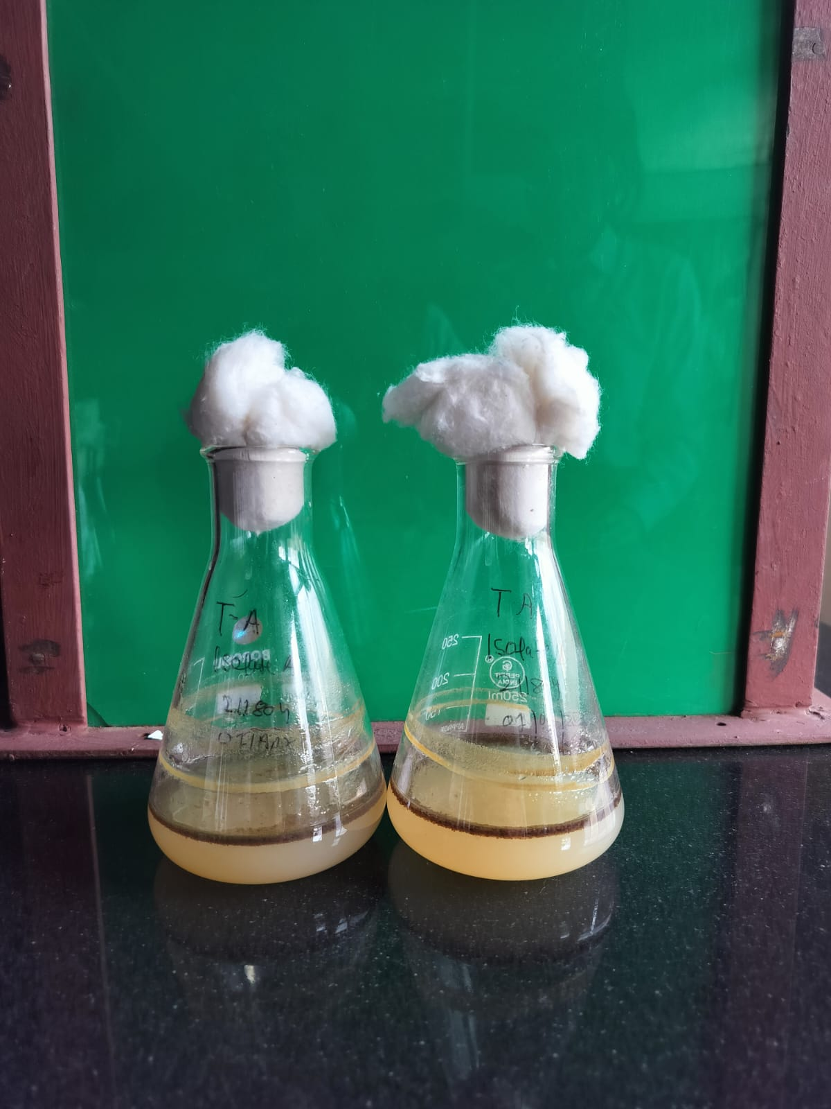

**Fig.1: Bacterial growth of Isolate A and isolate B**

**3.8 Optimization Analysis**

To enhance the growth of hydrocarbon-degrading bacteria, optimization studies were carried out in three successive stages:

* Evaluation of nitrogen sources
* Determination of optimal pH using the best nitrogen source
* Determination of optimal temperature at optimal pH with the selected nitrogen source

**3.8.1 Evaluation of Different Nitrogen Sources**

**Objective:**

To identify the most effective nitrogen source for supporting the growth of hydrocarbon-degrading bacteria in diesel-containing environments.

**Methodology:**

Three nitrogen supplements were selected for evaluation:

* Peptone (organic source)
* Yeast extract (organic source)
* Ammonium sulphate (inorganic source)

Each nitrogen source was individually incorporated into minimal salt (MS) broth containing diesel as the sole carbon source. Equal volumes of MS broth were prepared and sterilized via autoclaving. After cooling, 1 mL of actively growing bacterial culture (previously enriched in similar conditions) was inoculated into each flask.

The flasks were incubated at 37°C with shaking at 180 rpm for 7 days. Bacterial growth was monitored daily by measuring optical density at 600 nm (OD600) using a UV-Vis spectrophotometer.

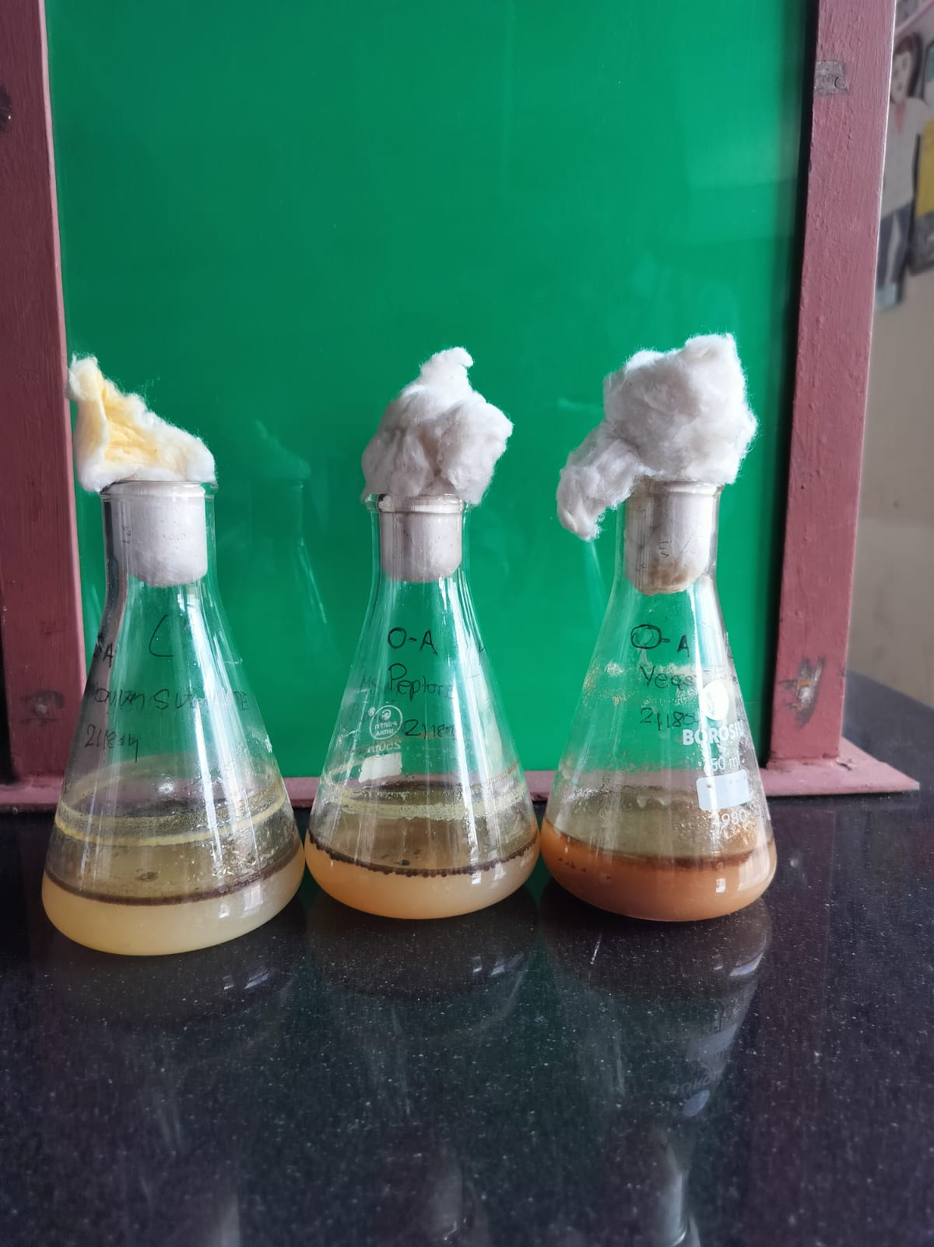

**Fig.2: Flasks with nitrogen sources peptone, yeast extract and ammonium sulphate**

**3.8.2 Optimization of pH Using Peptone as Nitrogen Source**

**Objective:** To determine the optimal pH for bacterial growth in MS broth containing peptone and diesel.

**Methodology:**

MS broth was adjusted to four different pH levels:

* pH 5.0
* pH 6.5
* pH 7.0
* pH 8.5

Adjustments were made using 1N HCl and 1N NaOH, and verified using a calibrated pH meter before autoclaving. After sterilization, each pH-adjusted medium was inoculated with 1 mL of standardized bacterial culture.

The flasks were incubated at 37°C with shaking at 180 rpm for 7 days, and OD600 was measured daily. Each pH condition was tested in triplicate.

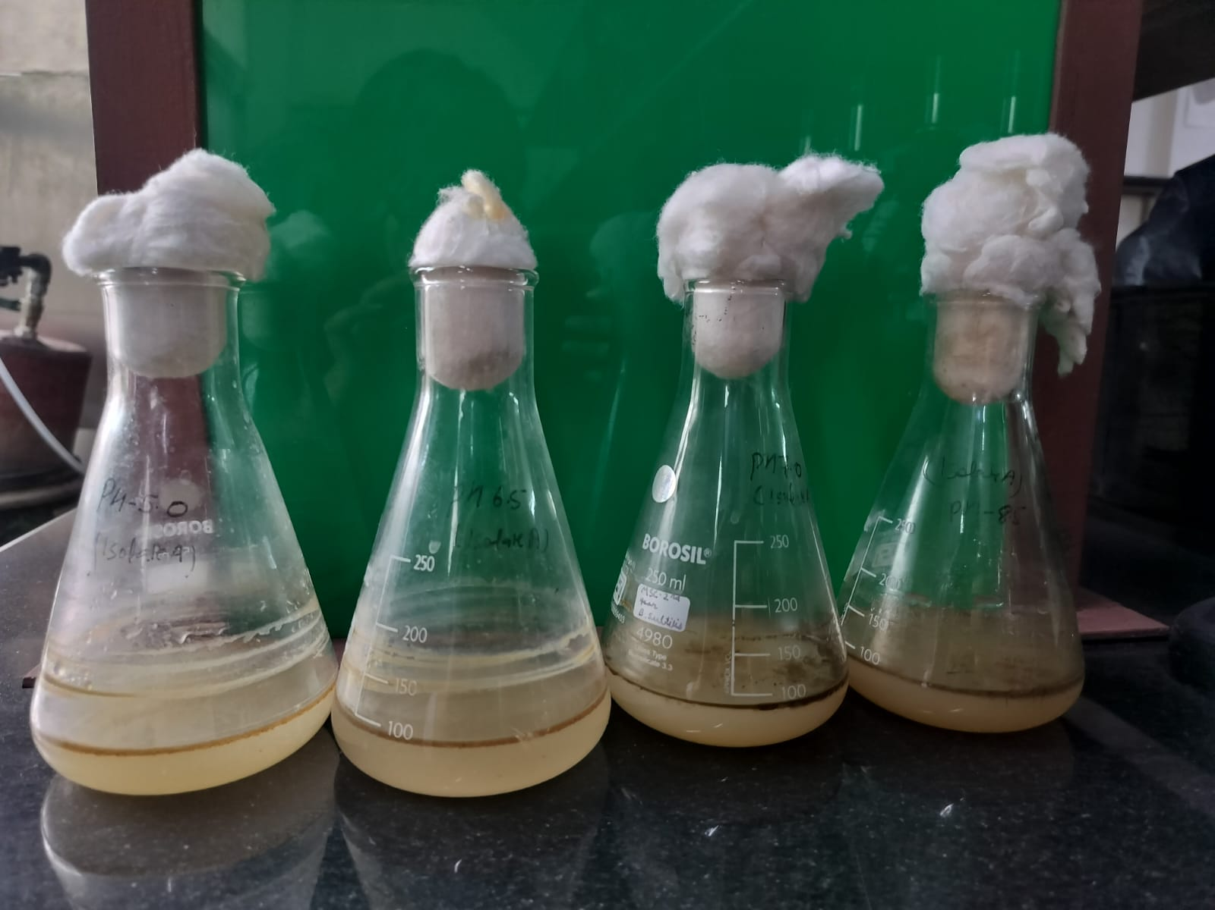

**Fig.3: Flasks with media at pH 5.0, pH 6.5, pH 7.0, and pH 8.5**

**3.8.3 Optimization of Temperature Using Peptone at pH 7.0**

**Objective:**

To determine the optimal incubation temperature for bacterial growth in MS media supplemented with peptone at pH 7.0.

**Methodology:**

MS broth at pH 7.0 was sterilized and inoculated with 1 mL of actively growing bacterial culture. The flasks were incubated at the following temperatures:

* 25°C
* 30°C
* 37°C
* 40°C

All cultures were incubated under 180 rpm shaking for 7 days, with OD600 measurements taken daily. Each temperature condition was tested in triplicate.

**CHAPTER-4**

**RESULTS**

**4.1. Isolation and Enrichment**

Soil samples were collected from an oil-contaminated site for isolating hydrocarbon-degrading bacteria. These samples were inoculated into Minimal Salt (MS) broth supplemented with diesel and burned engine oil, followed by incubation at 37°C for 7 days under shaking conditions (180 rpm).

A significant increase in turbidity was observed during incubation. The final optical density (OD₆₀₀) reached approximately 5.678, suggesting substantial bacterial proliferation and utilization of hydrocarbons as the sole carbon source.

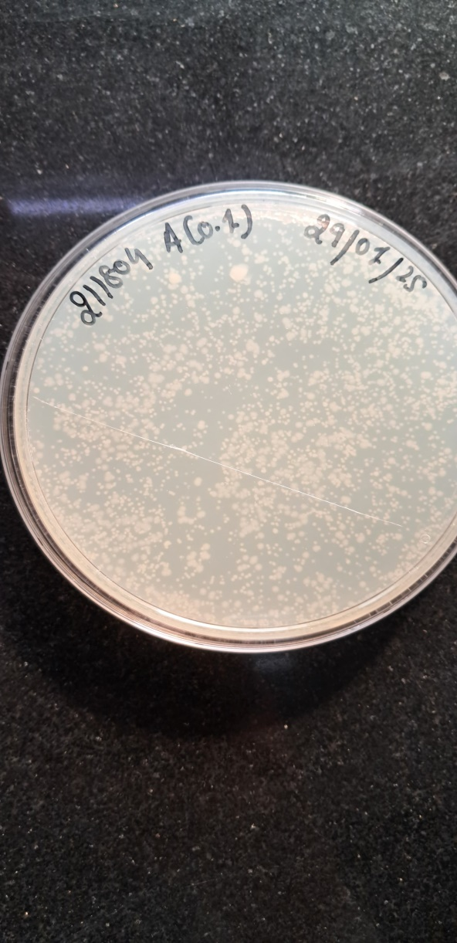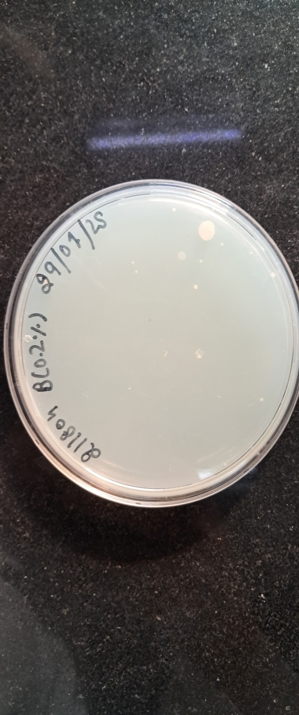

**Fig.4: Bacterial colonies of Isolates A and B grown on MS agar plates show dense growth**

**4.2 Morphological Observation and Gram Staining**

Post-enrichment, bacterial cultures were streaked on MS agar plates containing 0.1% and 0.2% diesel and engine oil. Within 3–5 days, visible colonies were observed and picked based on morphological characteristics. Gram staining revealed that all isolates were Gram-negative, exhibiting pink coloration under the microscope. This indicated the presence of organisms with a thin peptidoglycan wall and an outer membrane, typical of oil-degrading bacteria like *Pseudomonas and Acinetobacter*.

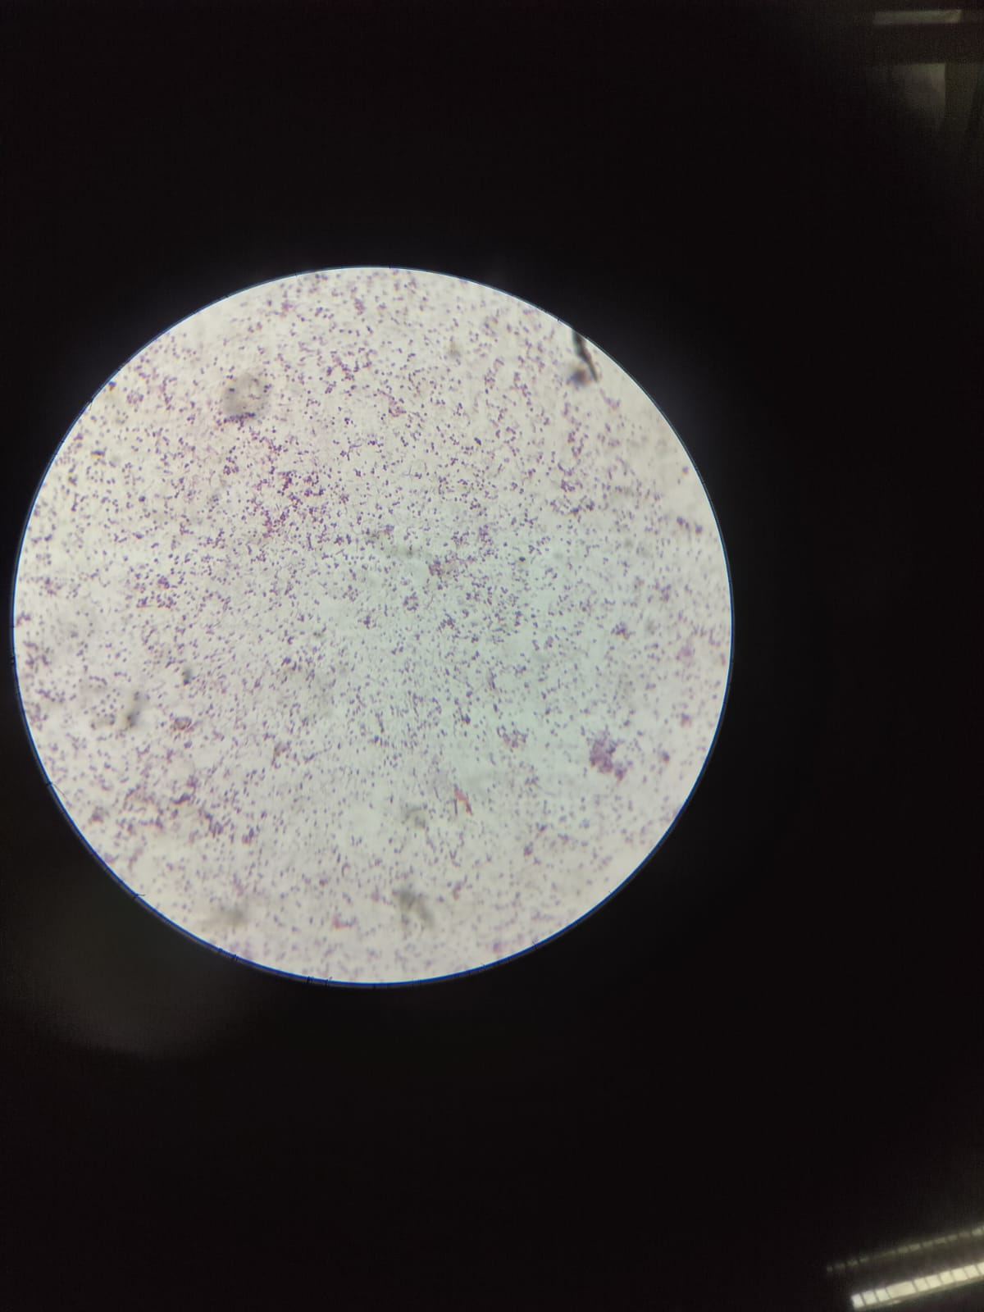

**Fig.5: Microscopic view showing Gram-stained bacteria isolated from oil-contaminated soil.**

**4.3 Biochemical Characterization**

To determine the metabolic profile of the isolates, the following biochemical tests were performed:

Table 4.3.1: Biochemical test results showing positive catalase, MacConkey, and mannitol tests for both isolates.

|  |  |  |  |
| --- | --- | --- | --- |
| Sr.no | Name of Test | Isolate A | Isolate B |
| 1 | Methyl red test | - | - |
| 2 | Catalase test | + | + |
| 3 | MacConkey Agar test | + | + |
| 4 | Mannitol test | + | + |
| 5 | Urea Hydrolysis test | - | - |
| 6 | Voges-Proskauer test | - | - |

These test results, combined with morphological observations, strongly indicate the isolates may belong to *Pseudomonas or Acinetobacter*, which are both capable of hydrocarbon degradation.

**4.4 DNA Extraction and Agarose Gel Electrophoresis**

Genomic DNA was extracted using the phenol-chloroform method. The extracted DNA was clear, colorless, and had an A₂₆₀/A₂₈₀ ratio between 1.8 and 2.0, indicating high purity. Agarose gel electrophoresis (1%) confirmed DNA integrity by showing sharp and distinct bands.

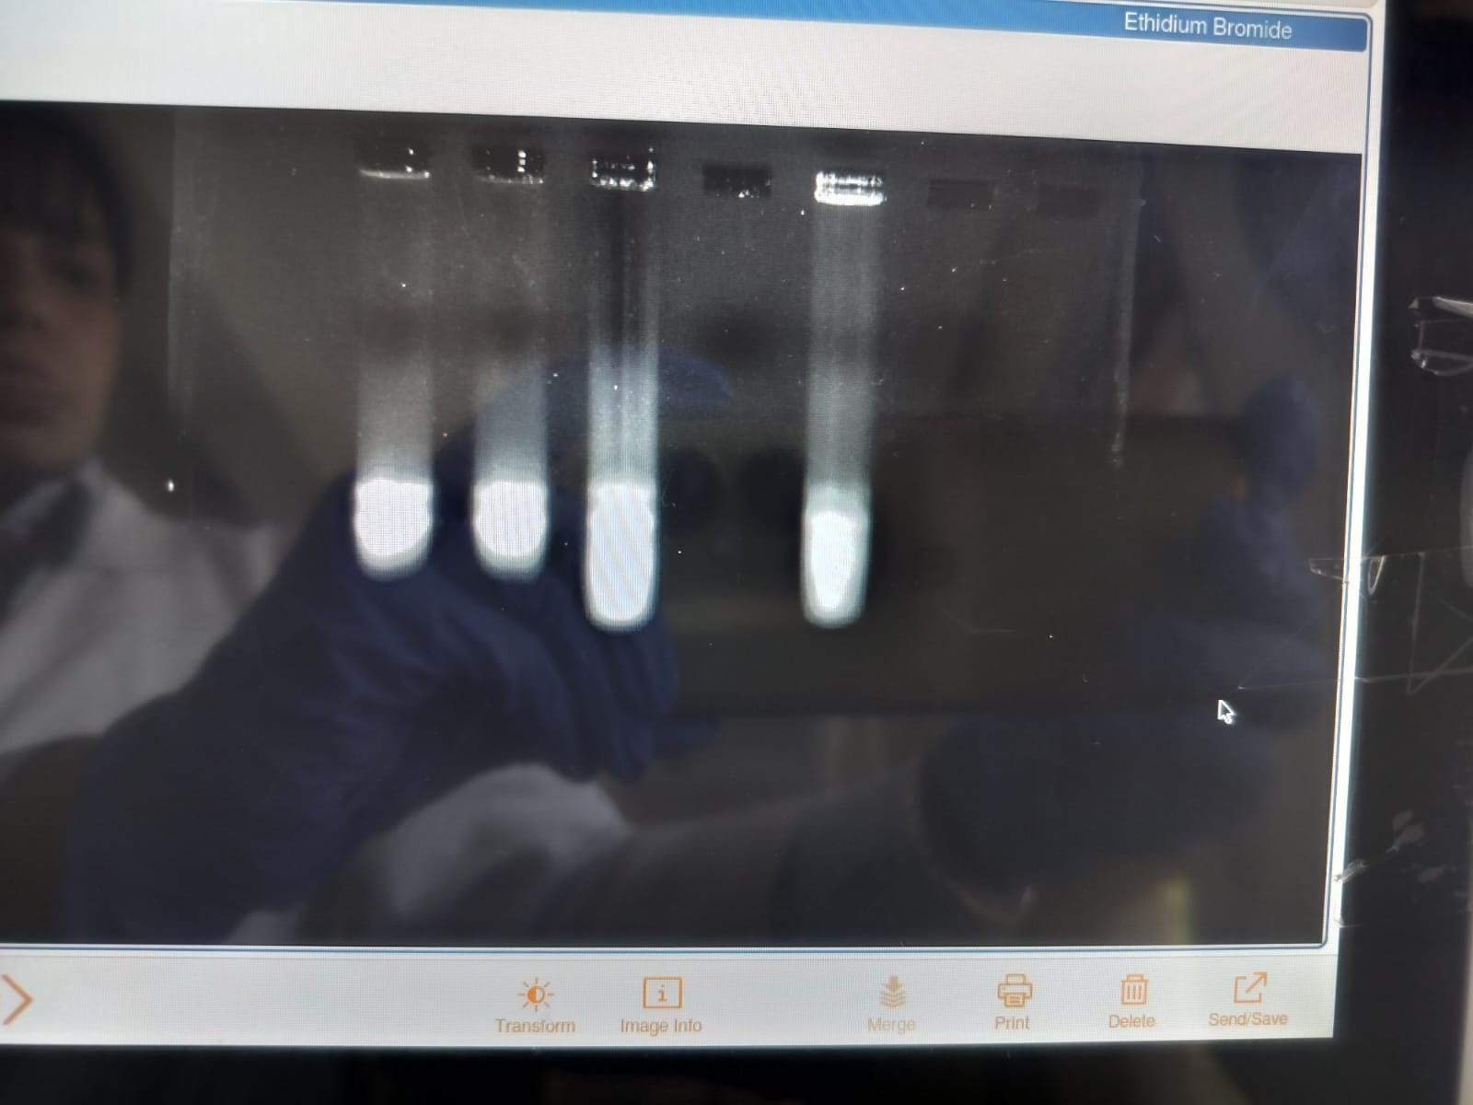

**Fig.6: Agarose Gel Electrophoresis of Extracted DNA**

**4.5 Turbidity Analysis**

To assess degradation efficiency, two isolates (A and B) were cultured separately in MS broth with diesel and engine oil, and OD₆₀₀ was recorded for 7 days.

* **Isolate A** showed rapid early growth, peaking at OD ~4.5 on Day 4, followed by a decline likely due to nutrient depletion or toxic metabolite accumulation.
* **Isolate B** demonstrated slower but sustained growth, reaching OD ~4.8 on Day 5, suggesting better adaptation for long-term degradation.

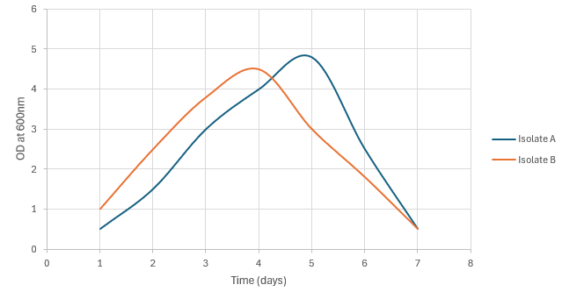

**Fig.7: Line graph comparing OD₆₀₀ of Isolate A (peaking at ~4.8, Day 5) and Isolate B (peaking at ~4.5, Day 4) in MS broth with diesel and engine oil over 7 days, showing Isolate B’s faster initial growth and Isolate A’s higher, sustained growth.**

Both isolates show promising bioremediation potential, with A being ideal for quick action and B for sustained degradation.

**4.6 Optimization Analysis**

**4.6.1 Effect of Nitrogen Source**

To determine the best nitrogen source for hydrocarbon-degrading bacterial growth, MS broth was supplemented with diesel and one of three nitrogen sources: ammonium sulphate, yeast extract, or peptone. Growth was monitored daily by measuring OD₆₀₀.

Table 4.6.1: OD₆₀₀ Values for Nitrogen Sources Over 7 Days

|  |  |  |
| --- | --- | --- |
| **Ammonium Sulphate (OD)** | **Yeast Extract (OD)** | **Peptone (OD)** |
| 1.587 | 0.576 | 1.058 |
| 3.076 | 2.076 | 2.576 |
| 5.861 | 4.567 | 4.067 |
| 5.567 | 6.587 | 6.867 |
| 4.567 | 5.068 | 5.568 |
| 3.765 | 3.654 | 3.086 |

**Interpretation:**

* Peptone supported the highest growth, peaking at OD 6.5 on Day 4, indicating it is the most effective nitrogen source.
* Yeast extract also supported substantial growth (OD 6.0 on Day 4).
* Ammonium sulphate led to moderate growth, peaking at OD 5.5, making it the least effective among the three.

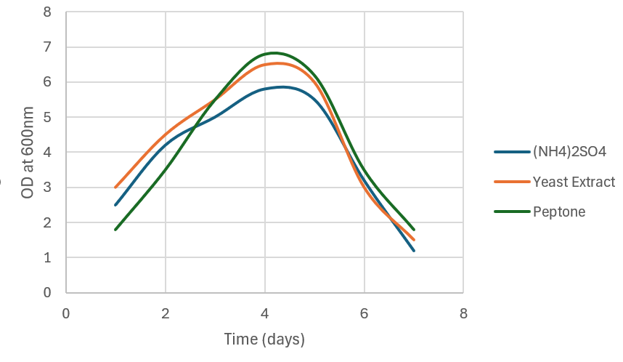

**Fig.8: Bacterial growth in MS broth with diesel and nitrogen sources (peptone, yeast extract, ammonium sulphate) over 7 days (OD₆₀₀); peptone highest (OD ~6.8, Day 4), then yeast extract, ammonium sulphate lowest.**

**4.6.2 Effect of pH**

To determine the optimal pH for the growth of hydrocarbon-degrading bacteria, MS broth containing diesel was adjusted to four different pH levels: 5.0 (acidic), 6.5 (slightly acidic), 7.0 (neutral), and 8.5 (alkaline). Cultures were incubated at 37°C for 7 days, and OD₆₀₀ values were recorded daily.

Table 4.6.2: OD₆₀₀ Values at Different pH Levels over 7 Days

|  |  |  |  |
| --- | --- | --- | --- |
| **pH 5.0** | **pH 6.5** | **pH 7.0** | **pH 8.5** |
| 0.294 | 0.321 | 0.671 | 0.367 |
| 0.623 | 0.534 | 0.937 | 1.382 |
| 1.483 | 1.684 | 2.379 | 1.827 |
| 1.743 | 2.025 | 2.969 | 2.418 |
| 2.172 | 3.567 | 4.897 | 3.988 |
| 3.897 | 4.763 | 5.987 | 4.987 |
| 1.234 | 2.453 | 2.765 | 1.765 |

**Interpretation:**

* Neutral pH (7.0) showed the highest OD₆₀₀, peaking at 5.987 on Day 6, confirming it as the optimal pH for bacterial growth.
* Slightly acidic pH (6.5) supported good growth (peak OD = 4.763), though slightly less than pH 7.
* Alkaline pH (8.5) allowed moderate growth, peaking at OD = 4.987.
* Acidic pH (5.0) resulted in the least growth, with a peak OD of 3.897, and rapid decline after Day 6.

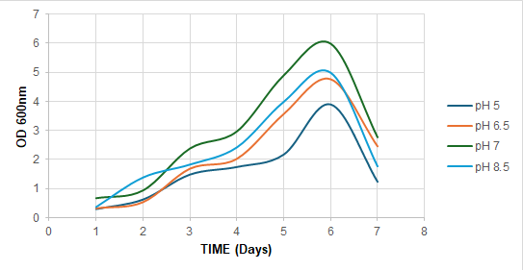

**Fig.9: Bacterial growth in MS broth with diesel at pH 5.0, 6.5, 7.0, 8.5 over 7 days (OD₆₀₀); pH 7.0 optimal (OD ~5.987, Day 6).**

The optimal pH for hydrocarbon-degrading bacterial growth was found to be pH 7.0. More acidic (pH 5) and alkaline (pH 8.5) conditions negatively impacted bacterial activity, likely due to enzyme denaturation or membrane instability. Hence, neutral pH conditions are recommended for efficient bioremediation applications.

**4.6.3 Effect of Temperature**

To investigate the effect of temperature on the growth of hydrocarbon-degrading bacteria, cultures were incubated at four different temperatures: 25°C, 30°C, 37°C, and 45°C in MS broth supplemented with diesel. OD₆₀₀ values were measured daily over a period of 7 days to monitor bacterial growth and determine the optimal temperature for biodegradation activity.

Table 4.6.3: OD₆₀₀ Values at Different Temperatures Over 7 Days

|  |  |  |  |
| --- | --- | --- | --- |
| **25°C** | **30°C** | **37°C** | **45°C** |
| 0.312 | 0.476 | 0.651 | 0.288 |
| 0.768 | 1.024 | 1.687 | 0.745 |
| 1.254 | 2.243 | 3.789 | 1.389 |
| 2.098 | 3.873 | 5.234 | 2.345 |
| 2.478 | 4.121 | 6.742 | 3.265 |
| 1.876 | 3.965 | 5.986 | 2.198 |
| 0.987 | 2.567 | 3.789 | 1.054 |

**Interpretation:**

* Optimal growth was observed at 37°C, with a peak OD₆₀₀ of 6.742 on Day 5, confirming it as the most favorable temperature for bacterial activity.
* At 30°C, moderate growth occurred (peak OD = 4.121), indicating suitable but suboptimal conditions.
* At 25°C, bacterial growth was limited, peaking at OD = 2.478, possibly due to reduced enzymatic activity.
* Growth at 45°C was minimal, suggesting heat stress or enzyme denaturation inhibited bacterial metabolism.

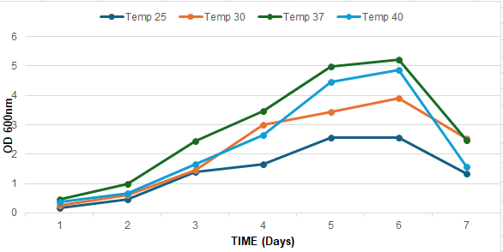

**Fig.10: Bacterial growth in MS broth with diesel at 25°C, 30°C, 37°C, 45°Cover 7 days (OD₆₀₀); highest at 37°C (Tem37, OD ~6.742, Day 5).**

The hydrocarbon-degrading bacterial isolates demonstrated maximum growth at 37°C, aligning with typical mesophilic behavior. Higher (45°C) or lower (25°C) temperatures led to suboptimal growth. Thus, 37°C is recommended for effective biodegradation during bioremediation processes.

**CHAPTER – 5**

**DISCUSSION**

This study focused on isolating, identifying, and optimizing bacteria from oil-contaminated soil to explore their potential for bioremediation. We successfully isolated bacterial strains that could use hydrocarbons as their only carbon and energy source, as shown by the cloudiness in enrichment cultures and clear colony growth on MS agar with diesel and engine oil. One isolate stood out, reaching a high optical density (OD₆₀₀ ≈ 5.678), which indicated strong growth and active hydrocarbon breakdown.

Through Gram staining, we found the isolate to be Gram-negative, a common characteristic of effective hydrocarbon degraders like *Pseudomonas and Acinetobacter.* Biochemical tests confirmed catalase activity, mannitol fermentation, and growth on MacConkey agar, but showed negative results for methyl red, Voges-Proskauer, and urease tests. These findings suggest the isolate might belong to the *Pseudomonas* family, known for their adaptability and versatile metabolism.

We extracted high-quality genomic DNA using the phenol-chloroform method, and agarose gel electrophoresis revealed clear, distinct bands, confirming the DNA's integrity. When comparing the growth of two isolates (A and B) over 7 days, Isolate A showed higher turbidity, indicating it was more efficient at degrading hydrocarbons.

Optimization experiments revealed that peptone worked best as a nitrogen source, with the bacteria thriving at pH 7.0 and 37°C. The isolate grew best in 0.1% diesel or engine oil, but its growth dropped at 0.2%, possibly due to hydrocarbon toxicity. Control setups with no hydrocarbons showed no growth, confirming that the bacteria relied solely on hydrocarbons for energy. Overall, these results demonstrate the promise of these local bacterial isolates for sustainable bioremediation of oil-polluted environments.

**CHAPTER 6**

**CONCLUSION AND FUTURE SCOPE**

This study successfully isolated and characterized bacteria from oil-contaminated soil, showcasing their potential for bioremediation. By using enrichment techniques with MS media containing diesel and engine oil, we grew bacteria that could thrive on hydrocarbons as their only carbon and energy source. A high optical density (~5.678) confirmed their active breakdown of hydrocarbons. The isolates were Gram-negative, a trait common among hydrocarbon-degrading bacteria like *Pseudomonas*. Biochemical tests supported this, showing positive results for catalase activity, growth on MacConkey agar, and mannitol fermentation, while tests for methyl red, Voges-Proskauer, and urease were negative. We also extracted high-quality genomic DNA using the phenol-chloroform method, with agarose gel electrophoresis verifying its purity for potential future genetic studies. Over 7 days, growth comparisons revealed that Isolate A outperformed Isolate B, indicating its superior degradation ability. Optimization tests showed that peptone was the best nitrogen source, with a neutral pH of 7.0 and a temperature of 37°C being ideal for growth. The bacteria thrived best at 0.1% hydrocarbon concentration, while 0.2% led to reduced growth, possibly due to hydrocarbon toxicity.

**Future Scope**

This study provides a solid starting point for using native bacteria in bioremediation, but there’s much more to explore. Moving forward, we could identify these isolates at the molecular level, study their hydrocarbon-degrading enzymes, and test them in real-world contaminated sites. Field experiments, larger-scale studies, and developing bacterial consortia could make them even more effective. Ultimately, these bacteria could offer an affordable, eco-friendly way to clean up oil-polluted areas, blending science with environmental care.

**BIBLIOGRAPHY**

1. A. Bento, F. C. Camargo, B. Okeke, and F. M. Frankenberger, “Comparative bioremediation of soils contaminated with diesel oil by natural attenuation, biostimulation and bioaugmentation,” Bioresour. Technol., vol. 96, 9, pp. 1049–1055, Jun. 2005, doi: 10.1016/j.biortech.2004.09.013.
2. A. Hamzah, A. Tavakoli, and A. Rabu, “Detection of toluene degradation in bacteria isolated from oil contaminated soils,” Sains Malays., vol. 40, pp. 1231–1235, 2011. (DOI unavailable)
3. B. Mishra, R. K. Jyot, R. C. Kuhad, and B. Lal, “Evaluation of inoculum addition to stimulate in situ bioremediation of oily-sludge-contaminated soil,” Appl. Environ. Microbiol., vol. 67, 4, pp. 1675–1681, Apr. 2001, doi: 10.1128/AEM.67.4.1675-1681.2001.
4. C. Holliger et al., “Contaminated environments in the subsurface and bioremediation: organic contaminants,” FEMS Microbiol. Rev., vol. 20, 3–4, pp. 517–523, Jul. 1997, doi: 10.1111/j.1574-6976.1997.00334.x.
5. C. S. Ezeonu, R. Tagbo, E. N. Anike, O. A. Oje, and I. N. Onwurah, “Biotechnological tools for environmental sustainability: prospects and challenges for environments in Nigeria—a standard review,” Biotechnol. Res. Int., 2012, doi: 10.1155/2012/450802.
6. D. Bhattacharya et al., “Detection of catabolic genes in bacterial strains degrading petroleum compounds,” Biotechnol. Lett., vol. 25, 22, pp. 1907–1912, Nov. 2003, doi: 10.1023/A:1026281416647.
7. D. Margesin, C. Zimmerbauer, and F. Schinner, “Monitoring of bioremediation by soil biological activities,” Chemosphere, vol. 40, 4, pp. 339–346, Feb. 2000, doi: 10.1016/S0045-6535(99)00218-0.
8. E. E. Erdogan, F. Sahin, and A. Karaca, “Determination of petroleum-degrading bacteria isolated from crude oil-contaminated soil in Turkey,” Afr. J. Biotechnol., vol. 11, pp. 4853–4859, 2012, doi: 10.5897/AJB11.3783.
9. E. K. Yakimov, K. N. Timmis, and P. N. Golyshin, “Obligate oil-degrading marine bacteria,” Curr. Opin. Biotechnol., vol. 18, 3, pp. 257–266, Jun. 2007, doi: 10.1016/j.copbio.2007.04.006.
10. E. Rosenberg, “The role of microorganisms in petroleum pollution,” Microb. Ecol., vol. 23, 2, pp. 97–105, Mar. 1992, doi: 10.1007/BF00172636.
11. E. W. Liebeg and T. J. Cutright, “The investigation of enhanced bioremediation through the addition of macro and micro nutrients in a PAH contaminated soil,” Int. Biodeterior. Biodegrad., vol. 44, 1, pp. 55–64, Jul. 1999, doi: 10.1016/S0964-8305(99)00054-7.
12. G. Bognolo, “Biosurfactants as emulsifying agents for hydrocarbons,” Colloids Surf. A Physicochem. Eng. Asp., vol. 152, 1–2, pp. 41–52, Jun. 1999, doi: 10.1016/S0927-7757(98)00629-2.
13. H. Bredholt, K. Josefsen, A. Vatland, P. Bruheim, and K. Eimhjellen, “Emulsification of crude oil by an alkane-oxidizing Rhodococcus species isolated from seawater,” Can. J. Microbiol., vol. 44, 4, pp. 330–340, Apr. 1998, doi: 10.1139/w98-020.
14. H. Harayama, T. Kasai, and A. Hara, “Microbial communities in oil-contaminated seawater,” Curr. Opin. Biotechnol., vol. 15, 3, pp. 205–214, Jun. 2004, doi: 10.1016/j.copbio.2004.04.002.
15. I. Bossert and R. Bartha, “The fate of petroleum in soil ecosystems,” Environ. Pollut., 1984. (DOI unavailable)
16. I. M. Banat, R. S. Makkar, and S. S. Cameotra, “Potential commercial applications of microbial surfactants,” Appl. Microbiol. Biotechnol., vol. 53, 5, pp. 495–508, May 2000, doi: 10.1007/s002530000410.
17. J. D. Desai and I. M. Banat, “Microbial production of surfactants and their commercial potential,” Microbiol. Mol. Biol. Rev., vol. 61, 1, pp. 47–64, Mar. 1997, doi: 10.1128/mmbr.61.1.47-64.1997.
18. J. E. Clarridge, “Impact of 16S rRNA gene sequence analysis for identification of bacteria on clinical microbiology and infectious diseases,” Clin. Microbiol. Rev., vol. 17, 4, pp. 840–862, Oct. 2004, doi: 10.1128/CMR.17.4.840-862.2004.
19. J. G. Leahy and R. R. Colwell, “Microbial degradation of hydrocarbons in the environment,” Microbiol. Rev., vol. 54, 3, pp. 305–315, Sep. 1990, doi: 10.1128/mr.54.3.305-315.1990.
20. J. Holt and S. Williams, Bergey’s Manual of Systematic Bacteriology, vol. 4, Baltimore, MD, USA: Lippincott Williams & Wilkins, 1989. (DOI unavailable)
21. J. P. Van Hamme, A. Singh, and O. P. Ward, “Recent advances in petroleum microbiology,” Microbiol. Mol. Biol. Rev., vol. 67, 4, pp. 503–549, Dec. 2003, doi: 10.1128/MMBR.67.4.503-549.2003.
22. M. Deleu, M. Paquot, P. Jacques, P. Thonart, and Y. F. Dufrêne, “Nanometer scale organization of mixed surfactin/phosphatidylcholine monolayers,” Biophys. J., vol. 77, 4, pp. 2304–2310, Oct. 1999, doi: 10.1016/S0006-3495(99)77067-2.
23. M. Sathishkumar et al., “Biodegradation of crude oil by bacterial strains isolated from oil-contaminated soil and water,” Afr. J. Biotechnol., vol. 7, 24, 2008, doi: 10.5897/AJB2008.000-5143.
24. M. Watanabe, Y. Kodama, S. Kaku, and A. Harayama, “Molecular characterization of bacterial populations in petroleum-contaminated soil,” Environ. Microbiol., vol. 2, 6, pp. 603–616, Dec. 2000, doi: 10.1046/j.1462-2920.2000.00143.x.
25. M.-E. Ekram, I. Sarker, M. S. Rahi, M. A. Rahman, A. K. Saha, and M. A. Reza, “Efficacy of soil-borne Enterobacter sp. for carbofuran degradation: HPLC quantitation of degradation rate,” J. Basic Microbiol., vol. 60, 5, pp. 390–399, May 2020, doi: 10.1002/jobm.201900626.
26. N. Das and P. Chandran, “Microbial degradation of petroleum hydrocarbon contaminants: An overview,” Biotechnol. Res. Int., 2011, doi: 10.4061/2011/941810.
27. P. J. Alvarez and T. M. Vogel, “Substrate interactions of benzene, toluene, and para-xylene during microbial degradation by pure cultures and mixed culture aquifer slurries,” Appl. Environ. Microbiol., vol. 57, 10, pp. 2981–2985, Oct. 1991, doi: 10.1128/AEM.57.10.2981-2985.1991.
28. R. C. Prince, “Bioremediation of marine oil spills,” Trends Biotechnol., vol. 15, 5, pp. 158–160, May 1997, doi: 10.1016/S0167-7799(97)01033-9.
29. R. C. Prince, “Oil spill dispersants: Boon or bane?” Environ. Sci. Technol., vol. 49, 11, pp. 6376–6384, Jun. 2015, doi: 10.1021/acs.est.5b00961.
30. R. K. Hommel, “Formation and physiological role of biosurfactants produced by hydrocarbon-utilizing microorganisms,” in Physiology of Biodegradative Microorganisms, Springer, 1997, pp. 107–119, doi: 10.1007/978-94-011-3452-1_5.
31. R. Marchal, S. Penet, F. Solano-Serena, and J. P. Vandecasteele, “Gasoline and diesel oil biodegradation,” Oil Gas Sci. Technol., vol. 58, 4, pp. 441–448, 2003, doi: 10.2516/ogst:2003028.
32. R. Vidali, “Bioremediation: An overview,” Pure Appl. Chem., vol. 73, 7, pp. 1163–1172, Jul. 2001, doi: 10.1351/pac200173071163.
33. S. Geetha, S. J. Joshi, and S. Kathrotiya, “Isolation and characterization of hydrocarbon degrading bacterial isolate from oil contaminated sites,” APCBEE Procedia, vol. 5, pp. 237–241, 2013, doi: 10.1016/j.apcbee.2013.05.041.
34. S. J. Varjani, “Microbial degradation of petroleum hydrocarbons,” Bioresour. Technol., vol. 223, pp. 277–286, Jan. 2017, doi: 10.1016/j.biortech.2016.10.037.
35. S. R. Peixoto, G. C. Vermelho, and V. M. Rosado, “Bacterial diversity in oil-contaminated soils from mangroves: A case study in Brazil,” Int. Biodeterior. Biodegrad., vol. 89, pp. 73–82, Apr. 2014, doi: 10.1016/j.ibiod.2013.12.012.
36. S. V. Mohan et al., “Remediation of petroleum-contaminated soils: A review,” Environ. Rev., vol. 14, 4, pp. 261–276, Dec. 2006, doi: 10.1139/a06-006.
37. T. R. Neu, “Significance of bacterial surface-active compounds in interaction of bacteria with interfaces,” Microbiol. Rev., vol. 60, pp. 151–166, Mar. 1996, doi: 10.1128/mr.60.1.151-166.1996.
38. W. Wang et al., “Application of metagenomics in bioremediation of petroleum-contaminated environments,” Microb. Biotechnol., vol. 9, 5, pp. 522–534, Sep. 2016, doi: 10.1111/1751-7915.12376.

